AASL Lesson Plan Template
GRADE: 6th  SUBJECT: LAB21 / Media  TEACHER: Carol Wellen  TEACHER’S E-MAIL: carol.wellen@fcps.org  SCHOOL: Ballenger Creek MS | ESTIMATED LESSON TIME:  Two 45 minute blocks
LIBRARY CONTEXT:  ___Fixed  _x_Flexible  ___Combination  ___Individualized instruction  ___Stand-alone lesson  ___Lesson in a Unit  _x_Multiple lessons in a unit | COLLABORATION CONTINUUM:  ___Cooperation  ___Coordination  _x_Collaboration  ___Data-driven Collaboration  Collaborated with Maya Massey, Lab 21 teacher, weeks of Sept 19th and 26th
AASL Standards for the 21st Century Learner:

AASL Standard 1: Inquire, think critically, and gain knowledge.
Skills:
1.1.4 Find, evaluate, and select appropriate sources to answer questions.
1.1.5 Evaluate information found in selected sources on the basis of accuracy, validity, appropriateness for needs, importance, and social and cultural context.

Responsibilities:
1.3.1 Respect copyright/intellectual property rights of creators and producers.

AASL Standard 3: Share knowledge and participate ethically and productively as members of our democratic society.
Skills:
3.1.4 Use technology and other information tools to organize and display knowledge and understanding in ways that others can view, use, and assess.
3.1.6 Use information and technology ethically and responsibly.

Responsibilities:
3.3.7 Respect the principles of intellectual freedom.

FCPS Library Media Standards:
LM Standard 2: Locate, evaluate and select information resources and technologies as part of an inquiry process.
LM 20.05 Evaluate sources to select those that best meet the information need
c. Use criteria to evaluate sources (accuracy, currency, authority, bias, scope, authorship, purpose and audience

LM Standard 3: Collect and evaluate information in an ethical manner as part of an inquiry process.
LM 30.02.c. Avoid plagiarism (direct quotations, keeping track of sources used for information, paraphrasing)

LM 30.03 Use an appropriate citation style to create a source list (MLA, APA, Chicago)
a. Explain the purpose of giving credit to sources of information
b. Locate appropriate information to complete entry
c. Independently and accurately give credit to sources of information
d. Use style manuals and citation generators to format entries correctly

FCPS Lab 21 Standards- grade 6
Standard 3 - Interpret and Communicate Information from Science, Technology, Engineering, and Mathematics
LAB21.6.30.04 - Evaluate and integrate multiple sources of information (e.g.: quantitative data, video and multimedia) presented in diverse formats
LAB21.6.30.05 - Develop an evidence-based opinion or argument

Standard 4 - Engage in Inquiry
LAB21.6.40.01 - Ask relevant questions, gather appropriate information, refine the question, and develop new questions
LAB21.6.40.02 - Explore appropriate Science, Technology, Engineering, and Mathematics disciplines related to a real world problem or issue

Standard 7 - Apply Technology Strategically
LAB21.6.70.02 - Analyze the limits and impacts of technology
LAB21.6.70.03 - Engage in responsible/ethical use of technology

Lesson overview (content, rationale, and purpose):  In this unit, students learn about social media and various pros and cons. They have to choose a stance on the essential question: “Is social media helpful or harmful to students?” and support their stance with research-based evidence. They will find evidence to support their opinion, and they need to respect copyright laws by citing their sources used. This unit teaches students research skills, but the process should be engaging because social media is a high interest topic for students and something most of them use every day. Once they have completed their research, they need to share their findings with the class using an online presentation tool.  In the first media center lesson, students will learn about the reliability of web resources and how to evaluate websites. In the second media center lesson, students will learn why it is important to cite the sources of their research, and how to do so. |  | Connection to Local or State Content Standards and the Common Core Standards  CCSS.ELA-Literacy.W.6.8  Gather relevant information from multiple print and digital sources; assess the credibility of each source; and quote or paraphrase the data and conclusions of others while avoiding plagiarism and providing basic bibliographic information for sources.
Collaboration process:

I collaborated with the Lab21 teacher, Ms. Massey, face to face and via email. Out of all of the Lab21 units, this one was an easy fit for collaboration. The unit focuses on digital citizenship and the research process, both of which are included in the library media standards as well. Sometimes it can be difficult to motivate students to do research, but social media is definitely a topic that students are interested in. Ms. Massey said that she would introduce the topic and the research project, and I would explain how to cite their research sources. After further discussion, we agreed that students could also use guidance in how to find reliable resources online, and that I could teach that as well. The entire unit will take about 3 weeks, allowing time for student research in the middle and presentations at the end.

Final Product:

The final product will be a digital presentation of their research findings. They should have a persuasive presentation to justify their opinion, and they should have multiple resources to support their stance. The entire presentation should be convincing, backed by research, and utilize various features available in the digital presentation software.

Librarian’s Lesson(s): Website Reliability and Why, When, and How to Cite Sources

Lesson 1 – Website reliability – Students will learn how to find good online resources and how to evaluate the websites they find as they are searching for information on their topic.
Lesson 2 – Citing Sources – Students will learn why it is important to cite sources, when you have to cite sources, and how to create a citation.

Objectives:  Essential Question: Is Social Media helpful or harmful to students?  Students will be able to:  - Evaluate whether an online website is a reliable resource for their research.  - Explain one reason why sources must be cited.  - Create a citation for an online resource. | Assessments:  Process  - Pre-assessment of real vs fake photos  Product  - Website evaluation form  - Site Reliability quiz  Self-Assessment  - Unit self-assessment using the “Like This” unit rubric
Instructional Plan:  Resources students will use:  ___Online subscription database:  _x_Websites  ___Books  ___Reference  ___Periodical/newspapers  _x_Others:  Computers/Laptops  Website reliability PowerPoint  RADCAB Evaluation form | Inclusion, adaptations, strategies for differentiation:  - Connecting to prior knowledge  - RADCAB Mnemonic  - Graphic organizer  - Verbal/linguistic, logical/mathematical, visual/spatial intelligences incorporated in this lesson
Instructional Activities: (See below)
_x_ Motivation, anticipatory set:
_x_Direct Instruction:
_x_ Modeling and Guided practice:
_x_ Independent practice:
_x_ Sharing and reflecting:

Prior Knowledge: Students should already be familiar with what social media is, various social media sites, and some of the pros and cons of using social media. Students should also be familiar with doing web searches on the internet.

Differentiation: I utilized UDL principles in planning this lesson. The information about evaluating websites will be presented in several ways – pictures, a slide show, and reviewing actual websites. Students will be engaged in several ways - by having student inquiry as a component of the unit, and by making the research project relevant to them. Finally, students will have multiple options for expressing what they have learned. Students have to present their research findings but they can choose what presentation software they want to use. They need to have evidence to support their findings, but there is no set format they have to follow for the presentation – they can be as creative as they like. Additionally, I incorporated various scaffolding tools like mnemonics and graphic organizers into this lesson.
For multiple intelligences, I utilized verbal/linguistic, logical/mathematical, and visual/spatial in this lesson. All of these are present in the website evaluation activity – students use their visual intelligence as they view the websites, the evaluation process requires students to use logic and reasoning to evaluate the sites, and they have to use their verbal intelligence as they are discussing RADCAB out loud and sharing their justifications.

Instructional Procedures:
LESSON 1: Website Reliability (45 min)
Essential Question: Is Social Media helpful or harmful to students?

Engagement: (10 min)
- Ask students to think about the question, “Is everything on the Internet true?”
- Show students the PowerPoint presentation and play a game called "Real or Fake." The presentation has viral images from the Internet, and students have to tell whether the photos are real or fake. Discuss how students came to their decision.
- Ask students how can these pictures exist if they are not real? (images can be modified, photoshop, etc.) Explain that anyone can publish anything online.

Direct Instruction: (10 min)
- Since you will be using websites in your research, you have to know how to recognize a reliable site. Anyone can publish a site. Many sites are not a good fit for your research project so spending time on them is a waste. Some sites can contain misinformation. Do you know any examples?
- Show students the fake websites - the Tree Octopus and Emoji As a Second Language.

- Walk students through the six criteria of the RADCAB evaluation method on the PowerPoint.
For a site to make the first cut, “it’s gotta be a RAD”: a site that is Relevant to your task, Appropriate for you, and with the right amount of Detail. Is it a useful site for you? Project a site (AAP article - Social Media and Kids) and model critical thinking using the questions on the handout for Relevancy, Appropriateness, and Detail.
- Once you decide it’s RAD, you have to check the CAB and make sure you aren’t headed down the wrong highway. This is part two of the method. Here are the questions: Is the information Current? Is the author of the site an Authority in the field? Is there Bias on the site? Let’s look at another site. Project another site (Positive Effects of Social Media) (The dangerous social media ‘epidemic’). Scroll down to bottom of homepage and check last updated information. Scroll down to bottom of homepage or up to the title bar to show the author. Discuss bias in terms of purpose for the web site. There is bias on a site when the authors’ purpose is to persuade you to believe what they believe.

Modeling and guided practice: (5 min)
- Show students one more website and model using the RADCAB list to evaluate it.
MySpace, Facebook and Other Social Networking Sites .
- Discuss how students know whether or not it is a useful site, referring back to the original criteria.

Independent practice: (10 min)
- Students will visit one more site and complete the website evaluation chart and reflection questions.
- Give students the evaluation chart with a site to evaluate. Have links available in Google Classroom or already pulled up on computers.
Is it RAD? Is it CAB? Finally, is it a RADCAB site or do you need to find another Web site? Students should explain in writing why the site is a good or poor choice for their research, including the criteria used to make their decision.
Debriefing and Closure: (Sharing and reflecting) (10 min)
- Come back together as a class to share findings.
- As time allows, pull up the various sites and have students share their evaluation and reasoning. Which sites passed the RADCAB test? Which ones would not be suitable for your Social media research?
- As students their work, encourage other students to discuss whether they agree or disagree with the choices made.
- Now when you have time to work on your research, what will you do?
- Remember, every time you consider web sites for your research needs, ask yourself “RADCAB?” before you accept their validity as a source of information.

Evaluation/ Assessment:

At the beginning of the lesson, students were pre-assessed on their understanding of real versus fake images that appear online. They indicated if they thought a picture was real with a “thumbs up” sign, and if they thought a site was fake, a “thumbs down” sign. We discussed each picture to get an understanding of why students thought something was real (“I’ve seen that before, I know it’s real”) or fake (it doesn’t make sense for the trees to not be moving if that tornado was real).
The main activity of the lesson was the RADCAB evaluation activity. Students have one site to evaluate - they have to go through and apply the RADCAB criteria, and write down why it does or does not meet the criteria. Additional differentiation in this activity is that students are in groups, all looking at the same website within their group. They can discuss their thought process with each other as they go through the RADCAB steps. Students will be evaluated on their understanding and application of the RADCAB criteria for evaluating web sites as demonstrated on their evaluation form. For each of the six criteria, they need to have a justification for why they thought it did or did not meet the criteria of a good website.
(See Student Products for samples)
The final summative assessment for the lesson is a Site Reliability quiz that the LAB21 teachers collaborated on using for all of their classes. The following class period as a warm up activity, students will be evaluated using the Smart Surfer quiz. (See Student Products for samples)

RADCAB Evaluation Form
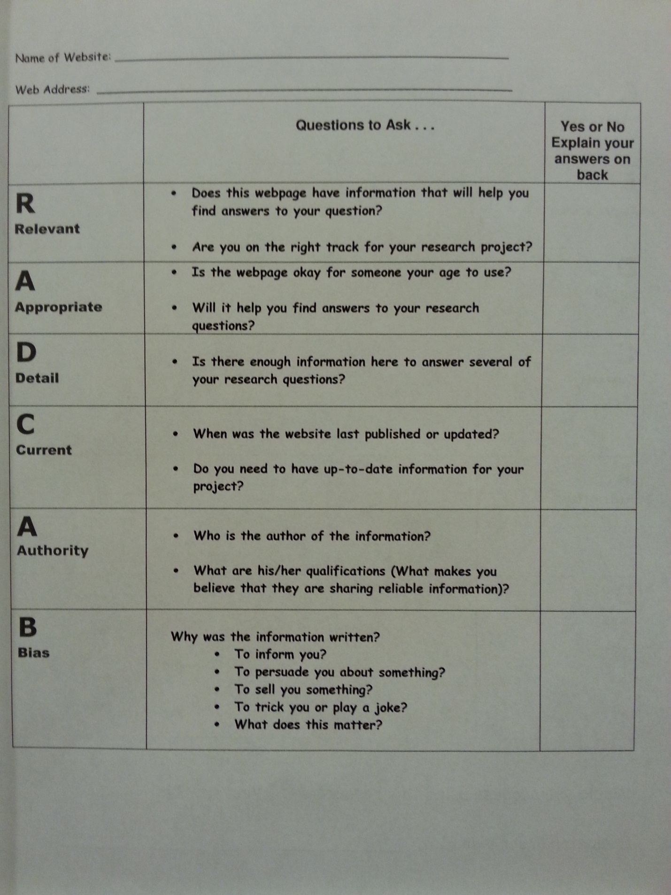
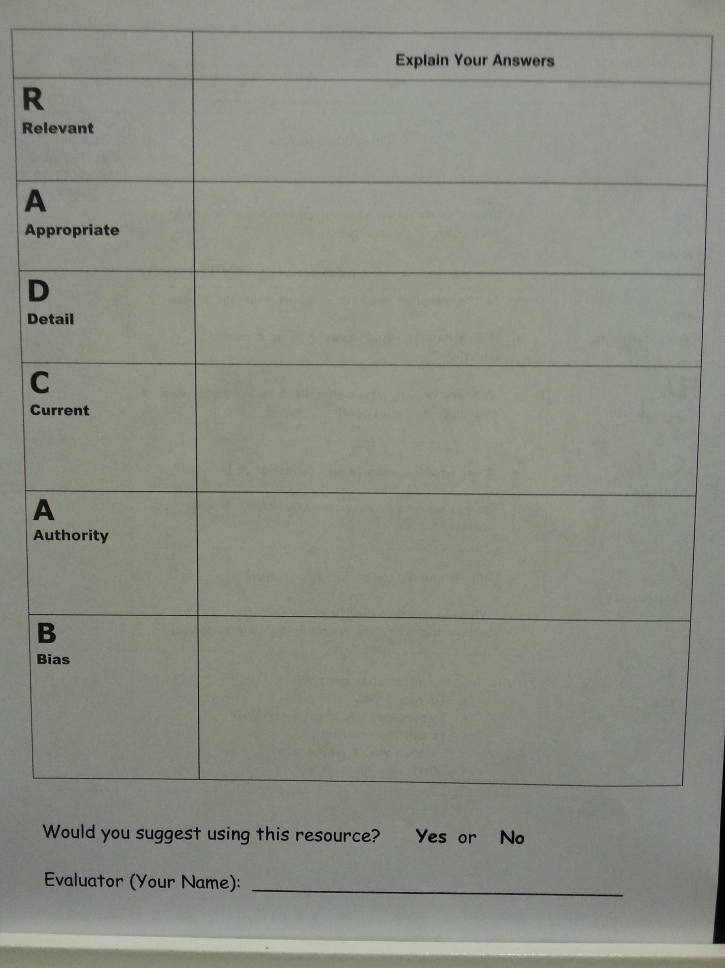

Site Reliability quiz

- Name __________________________________________________

- Which of the following is NOT an example of a URL extension?
  - .gov
  - .edu
  - .npr
  - .com

- Which of the following is the best indicator that a Web site is reliable?
  - The author of the site tells you the information is reliable.
  - The author of the site provides contact information and his or her qualifications.
  - The author links to his or her favorite Web sites.
  - The author states in bold letters that the site was proofread by a librarian.

- What does this URL tell you about the source? http://vos.ucsb.edu
  - It is associated with an educational institution.
  - It is an English teacher’s personal home page.
  - It is an article from a magazine.
  - It is from a government site.

- Evaluating content on the Web is important because…
  - Web authors are always less professional.
  - Web authors are always biased.
  - Anyone can publish on the Web. There’s no guarantee that what you’re reading is reliable.
  - Printed information is always more accurate than information found on the Web

- You found a site that seems to have credible information, but there is no date of publication. What do you do?
  - Panic.
  - Make up your own information.
  - Use the information anyway. You don’t have time to keep searching.
  - Try to find a site that has quality information AND a date of publication. Most reputable sites will have a copyright date.

- You are on a .gov site, but you can’t find an author. Can you use this site?
  - No because a site must have an author to be credible.
  - No because .gov sites are not reliable.
  - Yes because most .gov sites can be trusted. They are only published by the U.S. government.
  - Yes because you are in a rush and don’t have time to look elsewhere.

Happy surfing!

Student Products
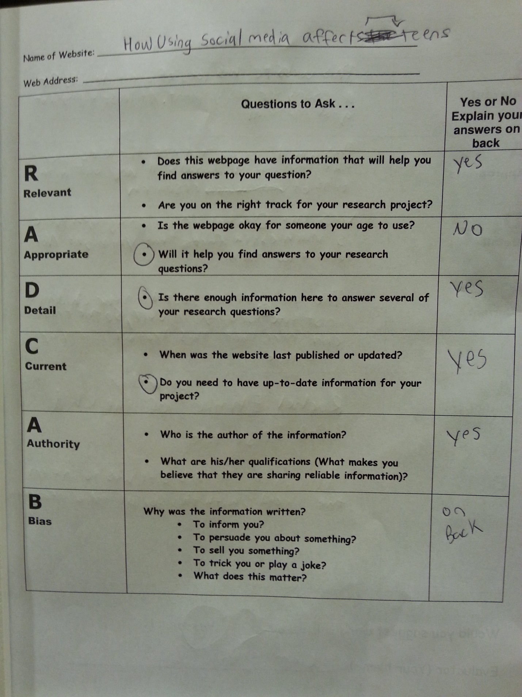
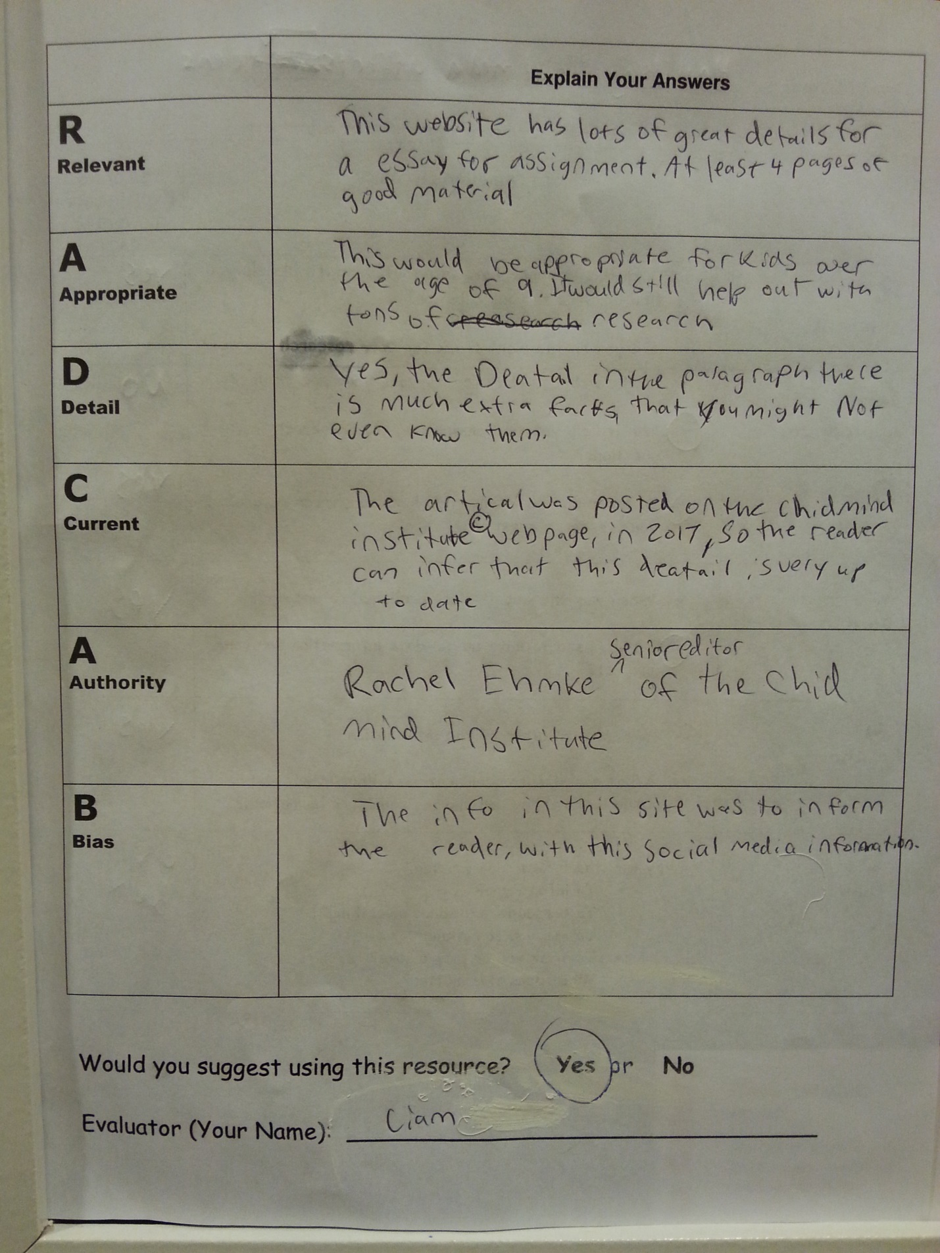

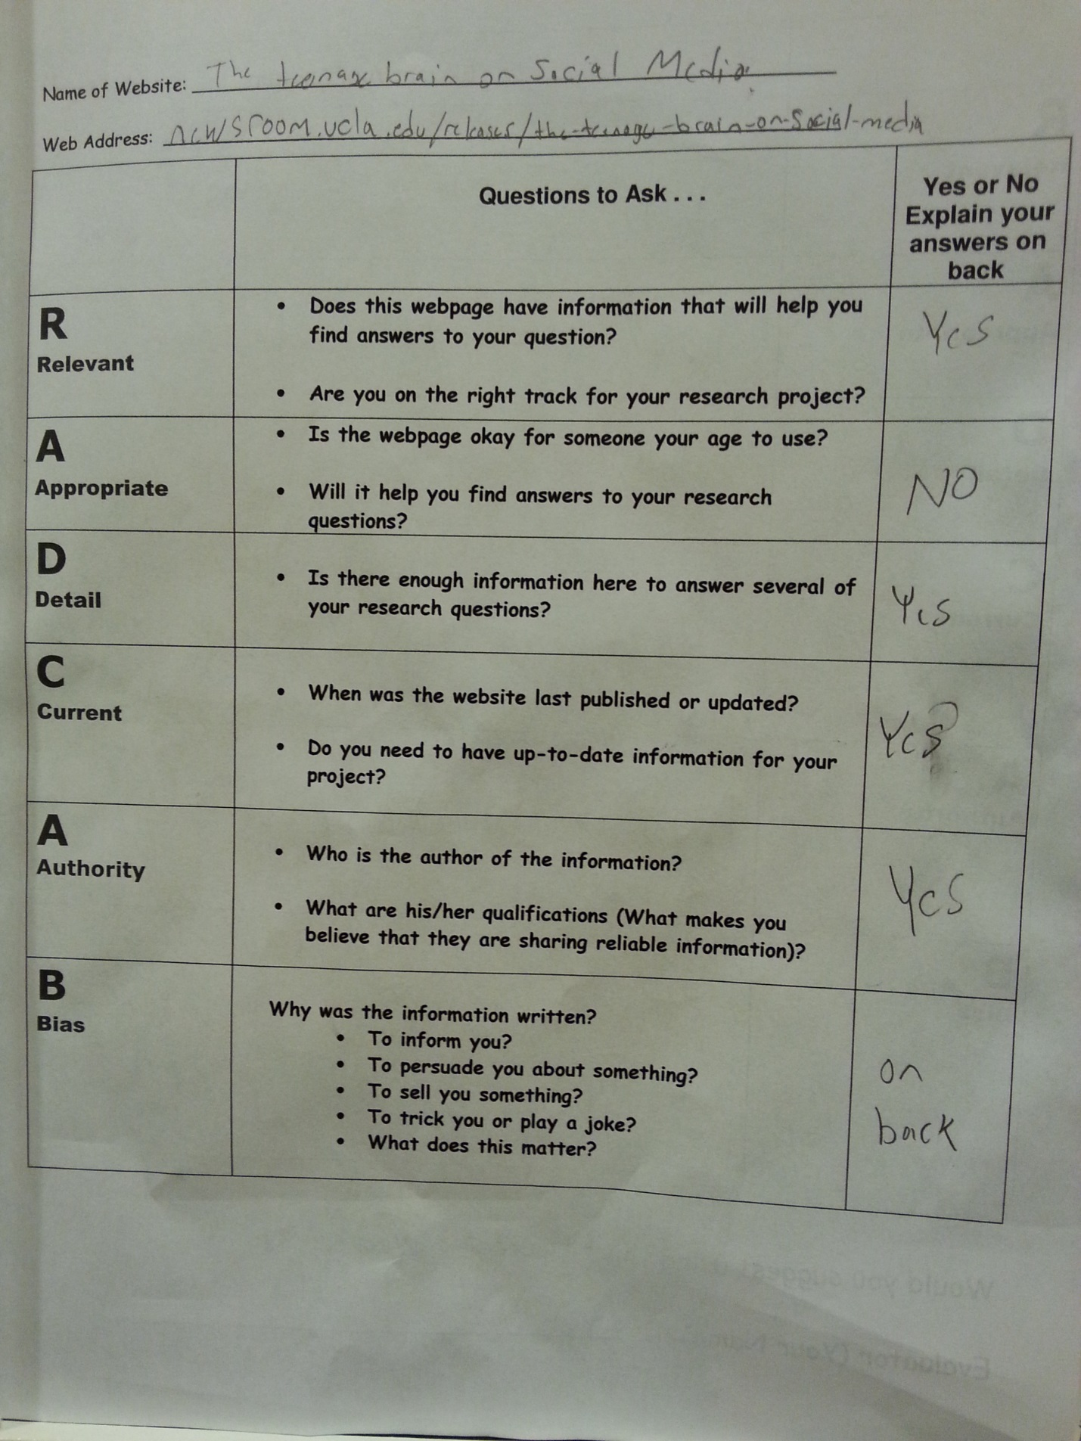
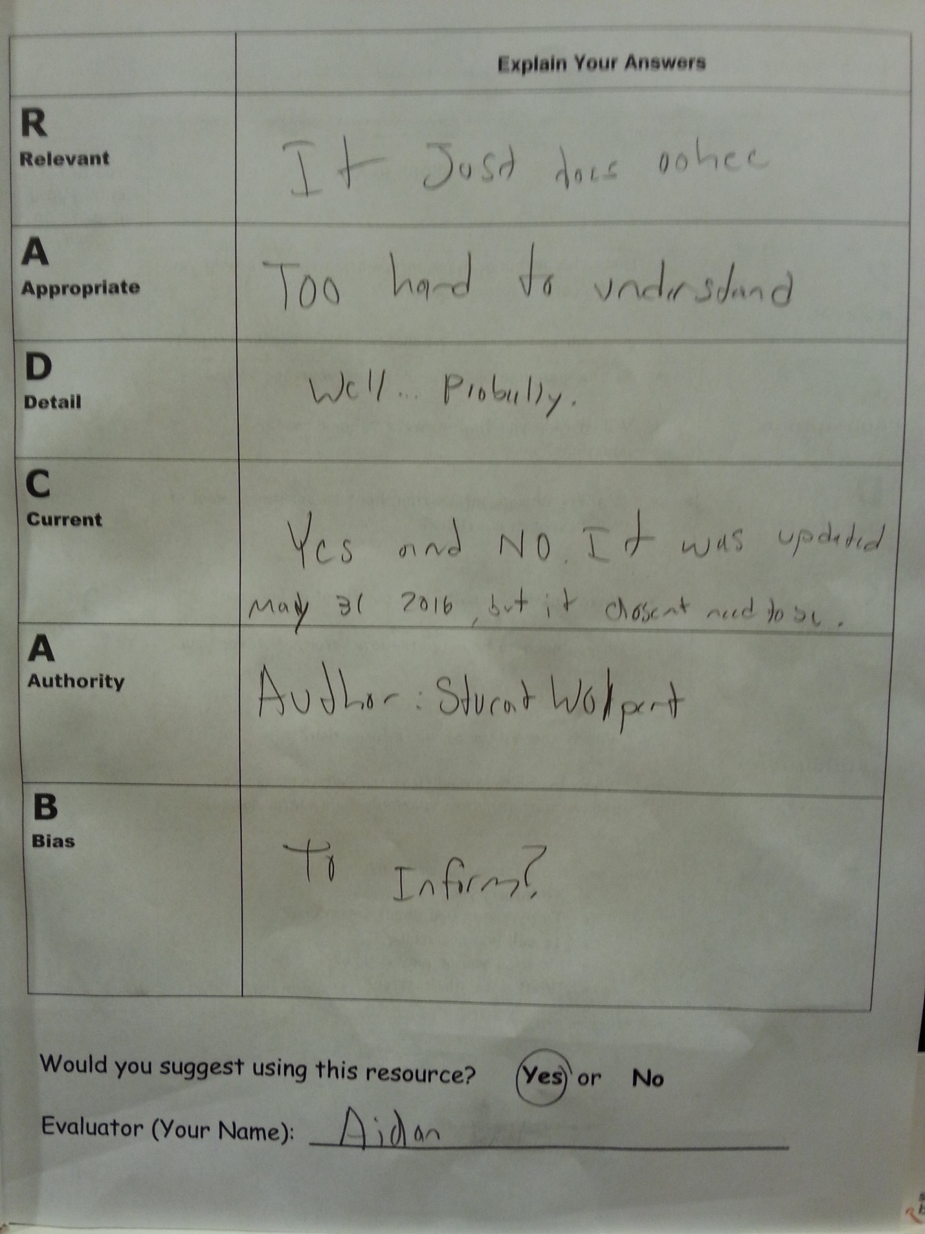

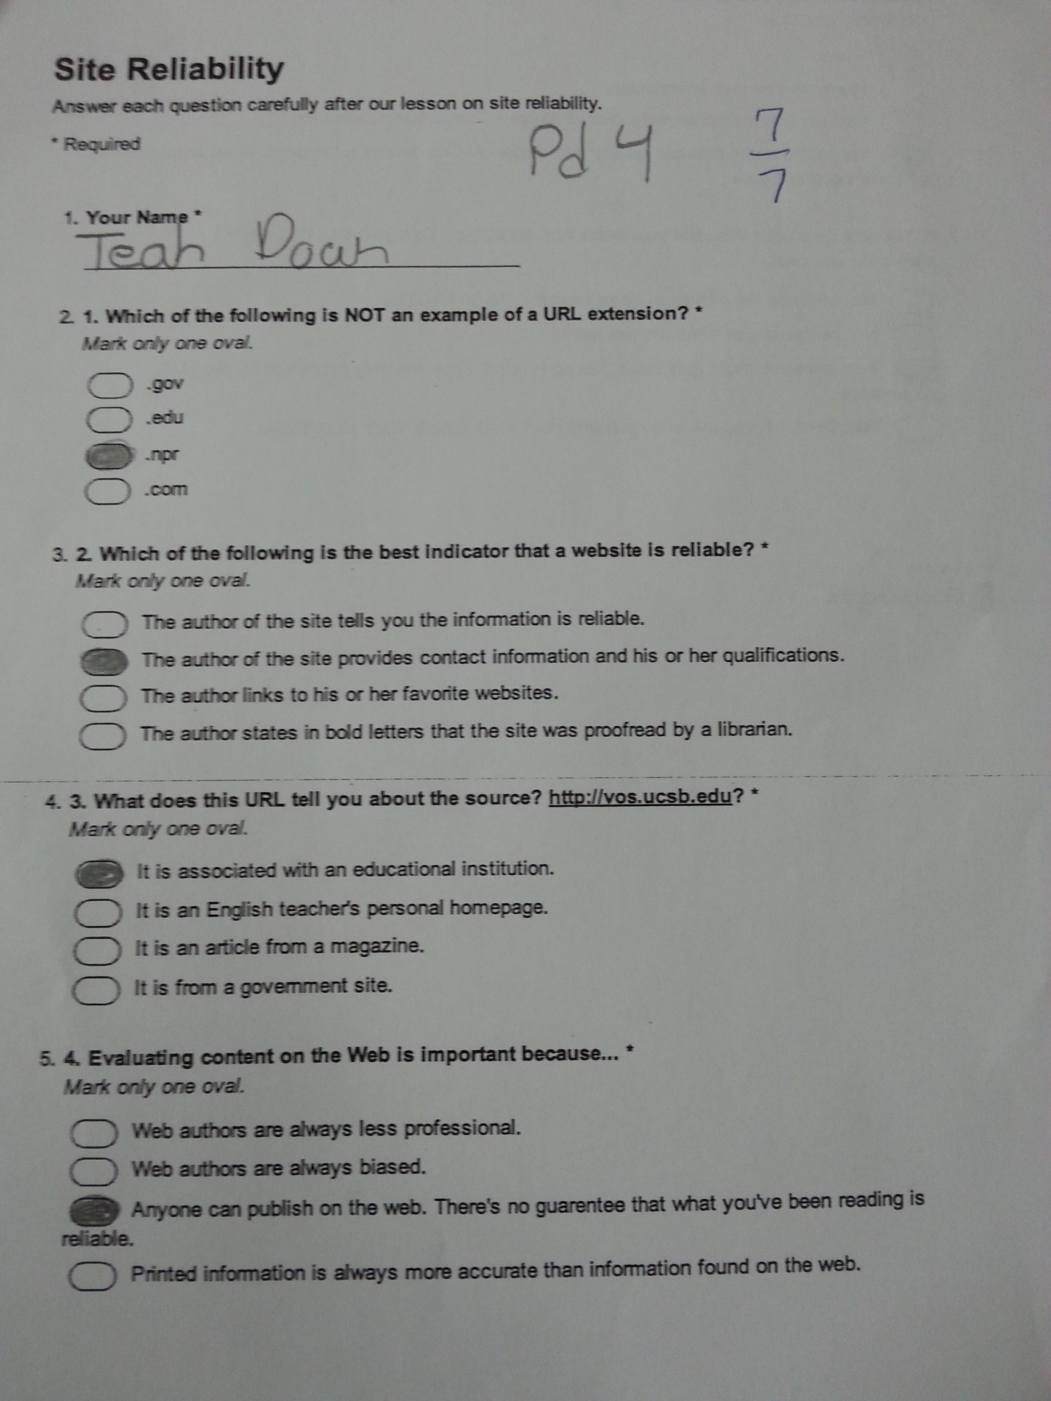

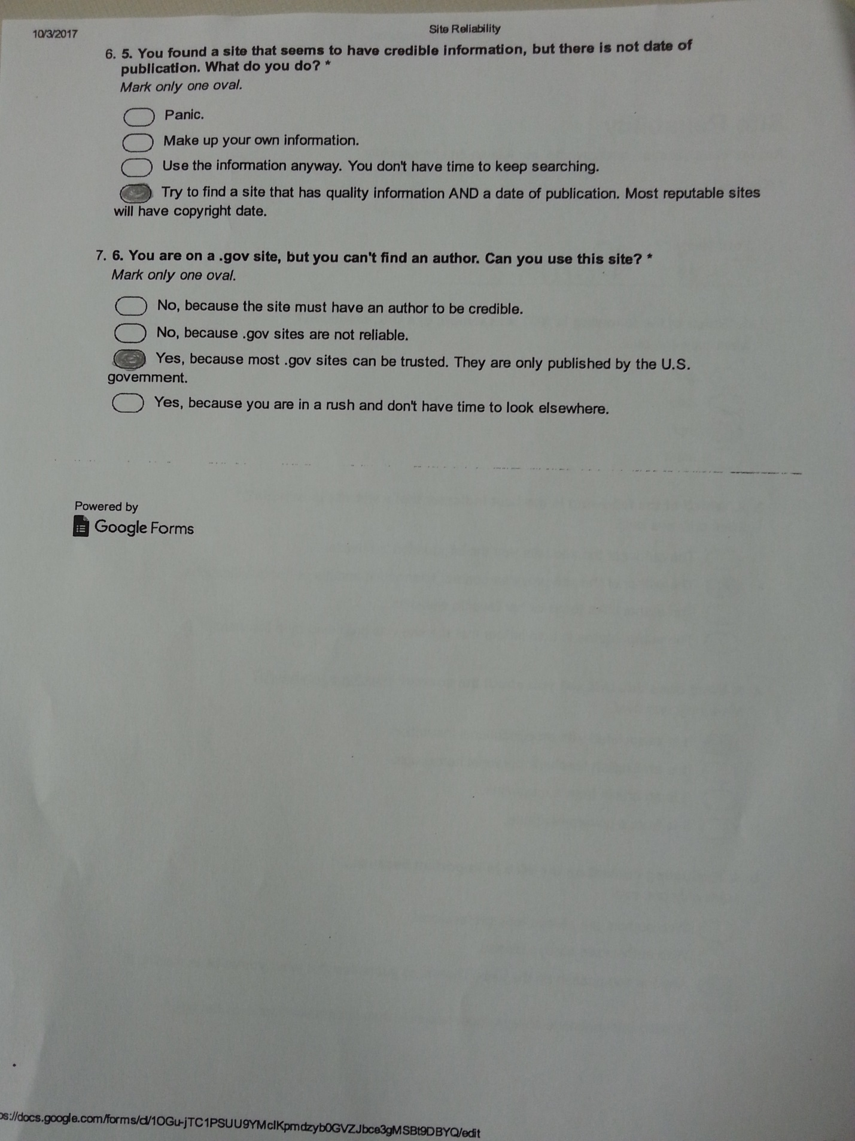

Student and Teacher Resources

Website Reliability PowerPoint https://docs.google.com/presentation/d/18x-CdJXs2I6zDHkLugHCtYH1Yi07tP18SreeHcMgF0U/edit?usp=sharing

RADCAB http://www.radcab.com/

Fake sites:
- Aluminum Foil Deflector Beanies
- Ban Dihydrogen Monoxide
- Case Analysis of a Historic Killer Tornado
- Dihydrogen Monoxide Research Division
- Jacopo di Poggibonsi
- Mankato (MN) Home Page
- MoonBeam Enterprises and Lunar Travel Agency
- History of the Fisher-Price Airplane
- Pacific Northwest Tree Octopus
- Visit Exciting Fredericton
- Xavier University - Emoji As a Second Language
Sites to evaluate:
- Social Media and Kids: Some Benefits, Some Worries
- The teenage brain on social media
- The Pros and Cons of Social Networking
- 6 Ways Social Media Affects Our Mental Health
- Why Instagram Is the Worst Social Media for Mental Health
- Social media websites can help and harm kids
- How Using Social Media Affects Teenagers
- 10 Reasons Why Social Media Is Great For Teenagers

Reflection of the Lesson:

Planning this lesson was a little challenging since I am only at Ballenger Creek two days a week, and my free time did not always match Ms. Massey’s planning time. We collaborated more over email and in passing, than actually sitting down and going over the content. I explored the Lab21 unit and various website evaluation resources, and then I reached out to Ms. Massey to confirm her thoughts on some of my ideas. If we had more time to sit down together, it would have been easier to do more differentiation for specific students. As it was, I tried to focus on UDL principles and adding scaffolding tools to the entire lesson that everyone could benefit from, like the RADCAB mnemonic and the graphic organizer.
This lesson was a lot of fun to teach. The students were definitely engaged in figuring out whether what they see online was true or not. I felt that it was an effective lesson because students were engaged in the concept of website reliability. It was easier for them to make an assessment of a picture versus an entire website. I knew that some students might believe that some of the pictures were real, but it was interesting to listen to their justifications. It was hard for some students to get past the idea that something they had known to be true could be false. When I showed the Emoji as a Second Language website, they were able to think a little more critically. The site looked very professional, and it was on a university website that ended in .edu, but they knew that the topic and content did not make sense for it to be real. When we finally scrolled down to the bottom and read that it was fake, it seemed to help them understand that some fake sites are made just for fun, or for advertising purposes. They have to really read over the entire site to determine whether something is reliable. At the end of the lesson, every single student was able to apply the RADCAB method to a website, but I think being engaged in the topic helped them stay focused to learn about the method.
The one part of the lesson that was not planned well was the assessment. I planned to collect the RADCAB papers at the end of the lesson and evaluate them. However, some students didn’t finish, and they kept the papers with them to be able to use the RADCAB method again in the future. One of the other Lab21 teachers put together a follow up quiz, and all of the Lab21 teachers decided to use that as the next day’s warm up. So that ended up being the assessment, but I did not have that assessment before I planned the lesson. After the quiz, Ms. Massey and I both graded her classes’ quizzes. I was pleased that all of the students in her classes scored a 71% or higher on the quiz. The questions that most students missed were about web extensions: .edu and .gov, and I had not covered that in my lesson. In the future, I either need to add web extensions to my lesson or plan out a better assessment ahead of time that covers everything I will present. It would also be beneficial to put together some sort of RADCAB reference sheet that students could keep and refer back to again.
Overall, my favorite aspect of this collaborative process was the actual co-teaching. This was not the first lesson that I taught with Ms. Massey, but I felt like we worked well together. During the lesson, I felt like everything she brought up reinforced and enhanced what I was covering. She was very flexible about how I should present the lesson, and overall I think the lesson went very well. During planning I was not sure whether I should use a different website evaluation method, because there were several different ones available. However, I feel like the RADCAB mnemonic is easy to remember, so I know it will be easy for Ms. Massey to continue to use it with students going forward. I will definitely spend more time collaborating on the assessment of future lessons. Luckily I have enjoyed collaborating so much, that I know I will have plenty of opportunity for collaborative lessons in the future.

Works Cited

American Association of School Librarians. Standards for the 21st Century Learner. American Library Association, 2007. Web. Accessed 1 Oct. 2017.
Curriculum Now. Frederick County Public Schools, n.d. Web. September 2017.
Essential Curriculum. Frederick County Public Schools, n.d. Web. September 2017.
Lomanno, Kari. "Savvy Surfers: Website Evaluation and Media Literacy." AASL Learning4Life Lesson Plan Database, AASL. Web. Accessed 1 Oct. 2017.
Paulson, Sara Lissa. "Catch RADCAB Sites: Which Sites Will You Ride?" From the Creative Minds of 21st Century Librarians, edited by Marilyn P. Arnone et al., Center for Digital Literacy, 2010, digital-literacy.syr.edu/data/From_The_Creative_Minds_Book.pdf.
RADCAB - Your Vehicle for Information Evaluation. Karen Christensson, 3 Aug. 2017. Accessed 1 Oct. 2017.
Terrebonne Parrish Library. "Why and When to Cite Sources." Tools for Teachers, Terrebonne Parrish Library, 2017. Accessed 1 Oct. 2017.

