What to Read?
A List of Great Books
from Mrs. Wellen

Carol Wellen
SLM 503

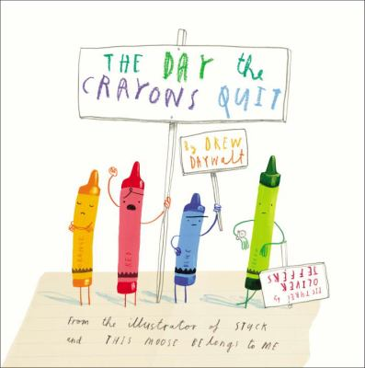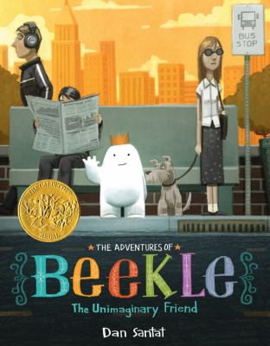

Picture Books
and Easy Readers

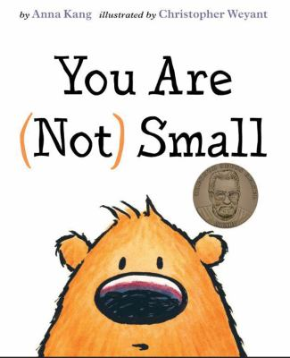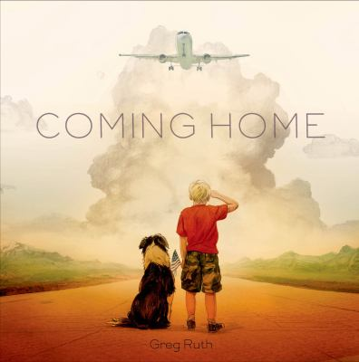

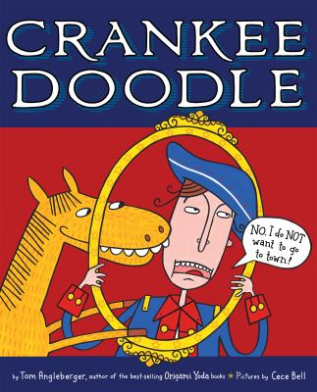 | Angleberger, Tom. Crankee Doodle. Boston:  Clarion, 2013.  Why did Yankee Doodle go to town? It turns out, it was not even his idea in the first place.  His pony wanted to go to town. Now you can find out why he went to town, why he put that feather in his hat, and why he called it macaroni.  Wilson’s MHR
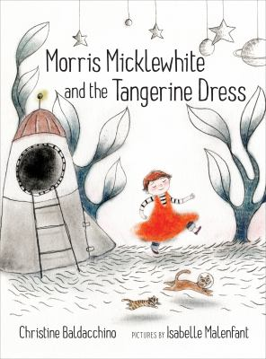 | Baldacchino, Christine. Morris Micklewhite  and the Tangerine Dress. Toronto: Groundwood, 2014.  Morris loves the fancy dress in the dress up center at school. Some of the kids make fun of him. Morris feels bad, and he is not sure he wants to go back to school. Then he has a dream about a space adventure. The next day, he decides to build a space ship by himself, but some of the other boys want to join him. Soon they realize it does not matter if you wear a dress, as long as you know how to have good adventures.  Wilson’s MHR
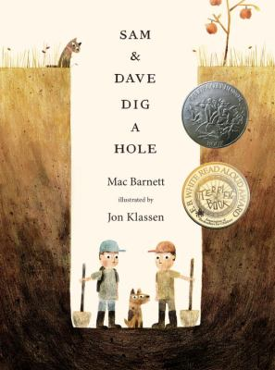 | Barnett, Mac. Sam and Dave Dig a Hole.  Somerville, MA: Candlewick, 2014.  Sam and Dave are on a mission… to find something spectacular. They dig a hole and keep digging. They keep looking but they never find anything, or so they think. Eventually they run out of snacks and take a nap. While they sleep, their dog digs for a bone. Maybe he has discovered something spectacular!  Wilson’s MHR, Caldecott Medal
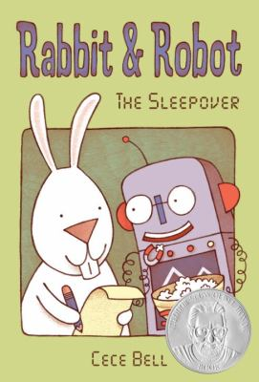 | Bell, Cece. Rabbit and Robot: The Sleepover.  Somerville, MA: Candlewick, 2012.  Rabbit’s friend Robot is coming over, so he makes a list of what they will do. Things do not go as Rabbit plans. Robot puts weird toppings on his pizza, Rabbit can’t find the tv remote, and Robot falls asleep in the middle of their game. But at the end of the day, Robot shows Rabbit that they did have fun after all.  Geisel Honor
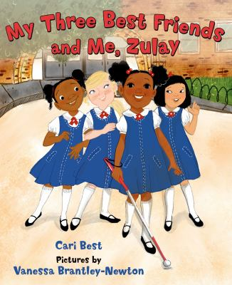 | Best, Cari. My Three Best Friends and Me,  Zulay. New York: Farrar Straus & Giroux, 2015.  Zulay and her best friends always help each other out. Zulay loves school, but she is blind and she does not love to practice walking with her cane. One day her teacher has a surprise: field day is coming. Zulay wants to run a race wearing her new pink shoes. Ms. Turner helps her feel the track with her cane. Zulay works hard so that when field day comes, she can run that race in her new pink shoes.  Wilson’s MHR
Daywalt, Drew. The Day the Crayons Quit.
New York: Philomel, 2013.

Duncan’s crayons are fed up. When he gets them out to color, he finds a bunch of letters instead. Each of his crayons has a complaint – some are tired, some want to color new things, some say they have been used too much. Duncan really wants to color, but he wants his crayons to be happy as well. In the end, he figures out the perfect way to make everyone happy.

Wilson’s MHR, Black Eyed Susan
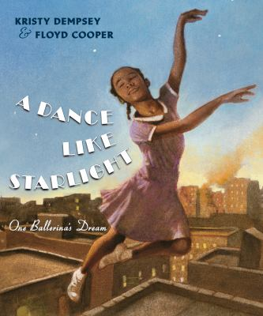 | Dempsey, Kristy. A Dance Like Starlight.  New York: Philomel, 2014.  A little girl in New York City dreams of becoming a ballerina. In her time, girls who look like her are not allowed to dance on stage with white girls. She takes ballet classes and works hard, but she worries her dream may never come true. Then she sees a picture in the paper of a prima ballerina who looks just like her. And her dreams have hope again.  ALSC Notable book
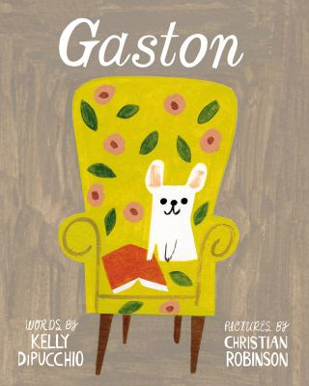 | DiPucchio, Kelly. Gaston. New York:  Atheneum, 2014.  Gaston works very hard to fit in with the rest of his family. When he meets a bulldog family in the park, he looks more like them, and their Antoinette looks more like a poodle. The families decide to switch. The problem is, Antoinette is too rough for the poodles, and Gaston is too gentle to be a bulldog. Their new families do not feel right, so they meet again and switch back. They may not look all alike, but their families feel just right.  Wilson’s MHR
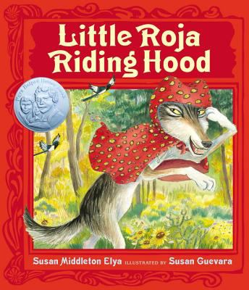 | Elya, Susan Middleton. Little Roja Riding Hood.  New York: G.P. Putnam’s Sons, 2014.  Little Roja needs to take some soup to her abuela who is sick. As she travels through the woods, she meets a sneaky lobo. The wolf tricks her into picking flowers while he steals her cape. The wolf pretends to be Little Roja and he goes to Grandma’s house, but Grandma is not fooled. Just as the wolf is about to eat Grandma, someone comes to save the day, but it is not who you think.  Pura Belpré Honor
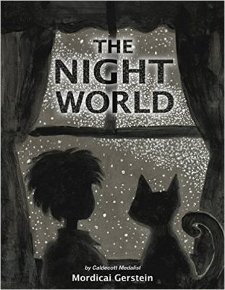 | Gerstein, Mordecai. The Night World. New York:  Little, Brown, 2015.  Everyone is asleep, but Sylvie the cat wants to go outside. As Sylvie and the boy creep outside, the world looks different at night. All the night animals say something is coming. As the night ends, the darkness changes and the animals go to sleep. The sunrise welcomes in the morning, with the promise that it is going to be a beautiful day.  Wilson’s MHR
Kang, Anna. You Are (Not) Small. New York:
Two Lions, 2014.

Two creatures meet, but they do not agree on who is big and who is small. One is bigger than the other, and one is smaller than the other. Each creature thinks they are normal size, but who is right? In the end, some new creatures come along who change both their minds.

Geisel Award
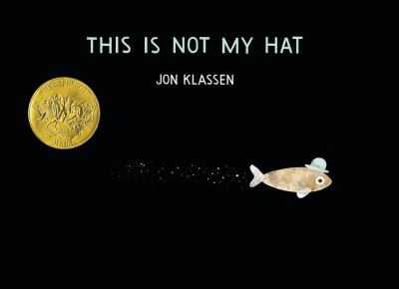 | Klassen, Jon. This is Not My Hat. Somerville, MA:  Candlewick, 2012.  This little fish is a thief. He stole a hat from a big fish while he was asleep. The hat fits the little fish better, and the big fish will not even notice that it is missing. As he makes his getaway, what the little fish is thinking does not match what actually happens.  Wilson’s MHR, Caldecott Medal
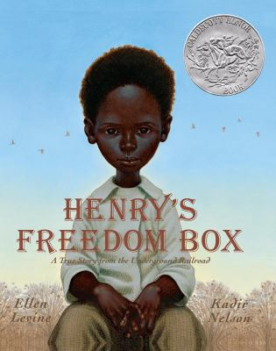 | Levine, Ellen. Henry’s Freedom Box. New York:  Scholastic, 2007.  As a boy, Henry Brown has a good life with his family. As a slave, he may not get to stay with them forever. Eventually Henry is given away and he must leave his family. When he is older he has his own family. He is happy until his family is torn apart again when his wife and children are sold. He knows he will never see them again. Finally he thinks about being free, and with some help, he hides and escapes to freedom.  Wilson’s MHR, Caldecott Honor
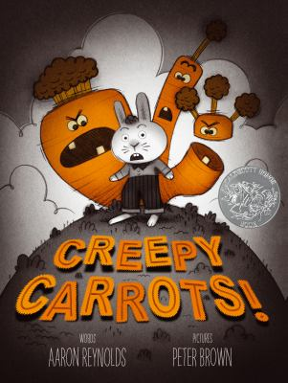 | Reynolds, Aaron. Creepy Carrots. New York:  Simon & Schuster, 2012.  Jasper Rabbit loves carrots. He cannot get enough of them… until the carrots start following him. Soon everywhere he looks, he sees creepy carrots, but his parents do not believe him. Finally Jasper figures out how to stop those creepy carrots. He will build a fence around that carrot field. Those carrots will never get out… and no more rabbits will get in.  Wilson’s MHR, Caldecott Honor, BES
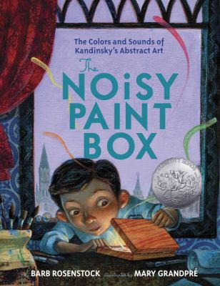 | Rosenstock, Barb. The Noisy Paint Box.  New York: Alfred A. Knopf, 2014.  Vasya Kandinsky was a proper Russian boy. He studied, practiced piano, and sat still during dinner, but when his aunt gave him a paint box, everything changed. He could hear the paint colors. His art teachers tried to get him to paint things, but Vasya wanted to paint the musical sounds he heard. He created something entirely new – abstract art.  Wilson’s MHR, ALSC Notable, Caldecott Honor
Ruth, Greg. Coming Home. New York: Feiwel
and Friends, 2014.

A little boy is waiting at the airport. As he waits, he walks past soldiers greeting their dogs. He sees soldiers taking pictures with their family. He waits and watches until he finally sees his special soldier – his mom.

Wilson’s MHR
Santat, Dan. The Adventures of Beekle.
New York: Little, Brown, 2014.

Beekle lives in a faraway place where all imaginary friends are born. He waits a long time but a child never chooses him. So he sets off on a journey. Everywhere he looks, he sees children who already have imaginary friends. Finally, he climbs to the top of a tree to wait for his friend. Someone finally comes, a friend who calls him, “Beekle.”
Wilson’s MHR, Caldecott Medal
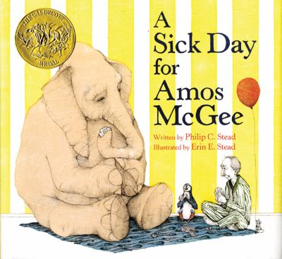 | Stead, Philip C. A Sick Day for Amos McGee.  New York: Roaring Brook, 2010.  Every day Amos McGee rises early and follows his routine at the zoo. He has work to do, but he always makes time to visit certain animal friends. Until one day when he wakes up with a cold and he has to stay home. At the zoo, the animals wait and wonder about Amos. Finally they go check on Amos at his house, and since he is sick, they take care of him like he always takes care of them.  Wilson’s MHR, Caldecott Medal
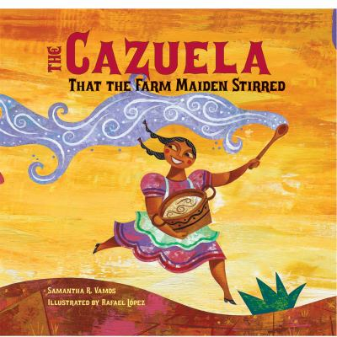 | Vamos, Samantha R. The Cazuela That the  Farm Maiden Stirred. Watertown, MA: Charlesbridge, 2011.  All the animals on the farm have something to put in the pot for dessert. When everything is mixed together, everyone dances and celebrates. They forget about the pot on the fire. It almost boils over, but they give it one last stir and it is ready. Everyone gives thanks for the delicious arroz con leche.  Wilson’s MHR
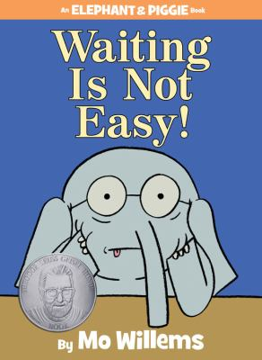 | Willems, Mo. Waiting Is Not Easy! New York:  Hyperion, 2014.  Piggy has a surprise for Gerald, and Gerald is so excited. The surprise is not here yet, so he will have to wait. Waiting is hard for Gerald. He is not sure if a surprise is worth all this waiting. In the end, they both agree the surprise was worth the wait.  Geisel Honor

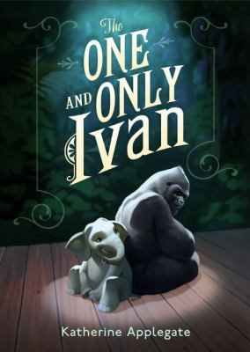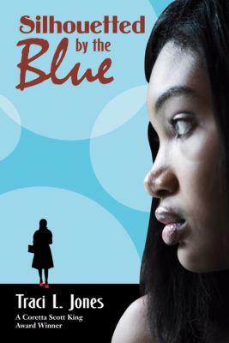

Fiction Books

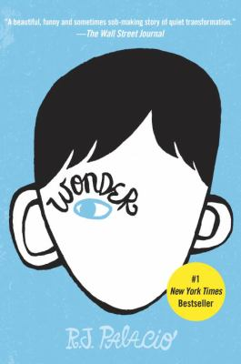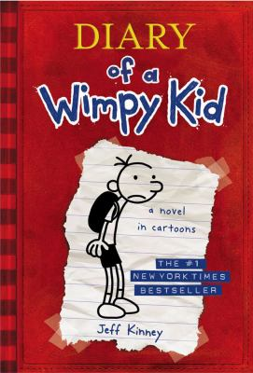

Applegate, Katherine. The One and Only Ivan.
New York: Harper Collins, 2012.

Ivan is a gorilla who lives in a cage at the mall. He has friends – a dog, an elephant, and a girl, but he has not seen another gorilla in years. His keeper used to be nice, but now he is not taking good care of the animals. Ivan is not happy, but he is not sure he can do anything about it. When a baby elephant comes to join their show, Ivan realizes things need to change.

Newbery, Wilson’s MHR
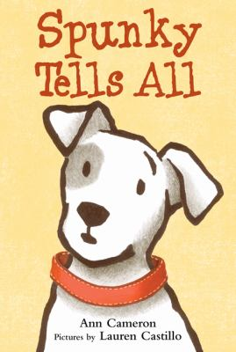 | Cameron, Ann. Spunky Tells All. New York:  Farrar Straus & Giroux, 2011.  Spunky is the Bates’ family dog. He is happy with his family, even if his humans do not understand his dog ways. He has a good life, until his family decides that he needs a friend. When they go to the animal shelter, instead of another dog, they bring home a cat. Fiona the cat turns Spunky’s life upside down, and he does not know what he can do.  Wilson’s MHR
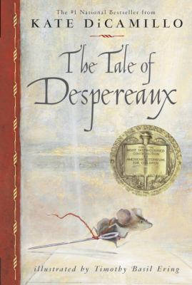 | DiCamillo, Kate. The Tale of Despereaux.  Read by Graeme Malcolm. Listening Library, 2003. CD.  This is a story about a rat who kidnaps a princess and the mouse who tries to save her. The mouse is sent to the dungeon for talking to the princess. The rat is tired of people screaming when he wants to get a glimpse of sunlight. The princess is sad that her mother has died, and that soup is now outlawed in the kingdom. Her servant girl just wants to be a princess, like her. Down in the dungeon, all their stories come together, and Despereaux must find the courage to save the day.  Newbery, Wilson’s MHR
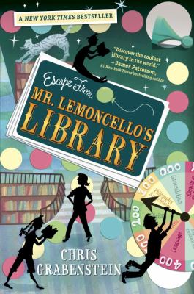 | Grabenstein, Chris. Escape From  Mr. Lemoncello’s Library. New York: Random House, 2013.  Kyle Keeley loves playing games and beating his older brothers. So when he finds out his favorite game maker designed the town’s new library, he cannot wait to see it. He does not realize that once he is inside, the real adventure is finding a way out of the library. He and his friends have to find clues and solve riddles. The first one out gets the ultimate prize.  Black Eyed Susan
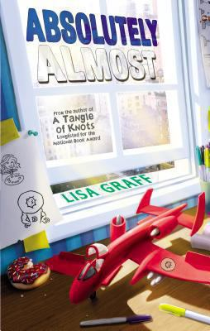 | Graff, Lisa. Absolutely Almost. New York:  Philomel, 2014.  Albie notices a lot of things. Mostly he notices that he is never quite good enough at the things he tries to do. He is almost able to give the right tip to the delivery guy. He is almost able to pass his spelling test. Now in fifth grade he is willing to try anything to go from being almost to being great.  Wilsons MHR
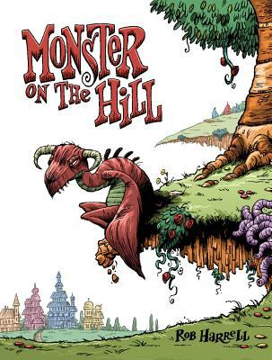 | Harrell, Rob. Monster on the Hill. Atlanta:  Top Shelf Productions, 2013.  Long ago, all towns had monsters. The monsters would come down from their caves and scare people, and the people loved it. It was as exciting as the scariest roller coaster. So of course the people of Stoker-on-Avon are upset that their town monster has not scared them in a long time. Finally Dr. Wilkie goes up the hill to meet the monster and find out if he can help him be scary again.  ALSC Notable Book
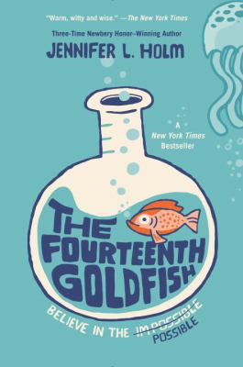 | Holm, Jennifer L. The Fourteenth Goldfish.  New York: Random House, 2014.  Ellie’s parents want her to find her passion. They hope she will be passionate about theater like they are. Ellie thinks maybe she was born into the wrong family. Then a new kid shows up who looks a lot like Ellie’s grandfather, only younger. He says he has discovered the secret to reverse aging. Now he needs Ellie’s help to share his scientific discovery with the world.  Wilson’s MHR, ALSC Notable Book
Jones, Traci L. Silhouetted By the Blue.
New York: Farrar Straus & Giroux, 2011.

Serena has the lead in the school musical, but now she is not sure if she can be in the musical after all. Her mom died a year ago, and her dad is dealing with “the blues”. He will not get out of bed, so Serena has to take care of everything. She has to buy food, cook dinner, wash clothes, and take care of her brother. She does not know how she will have the energy to perform, or how she can get her dad to get up and get over his blues.

Wilson’s MHR
Kinney, Jeff. Diary of a Wimpy Kid: Greg
Heffley’s Journal. New York: Amulet, 2007.

Now that Greg is in middle school, he is trying to act cool. It is hard to be cool when his best friend is clueless, and he has to avoid getting beat up by bullies. Then somehow, his best friend becomes more popular than Greg, and he is not sure he can handle it. Greg needs to find a way to get his best friend and his life back to normal.

Wilson’s MHR
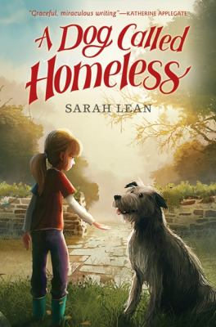 | Lean, Sarah. A Dog Called Homeless.  New York: Katherine Tegen, 2012.  Cally’s mom died a year ago. Nothing has been the same, and no one talks about her mom anymore. Cally stops talking for a day as part of a school fundraiser. It is nice being silent, so she decides not to talk at all anymore. Lately there is a dog that seems to be showing up wherever she is. She feels a connection to this dog, but she does not know how she can keep it and get her dad to talk about her mom again.  Wilson’s MHR
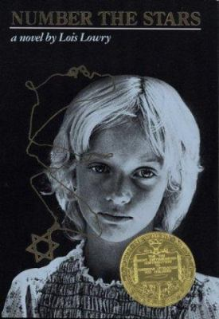 | Lowry, Lois. Number the Stars. Boston:  Houghton Mifflin, 1989.  Annemarie’s family must hide their Jewish neighbors from the Nazis. The Nazis are planning to take away all the Jews in Denmark. Annemarie goes with her friend Ellen to a farm in the country. There, they meet up with other people who are helping Jews escape. This story is based on what really happened in Denmark during World War II.  Newbery, Wilson’s MHR
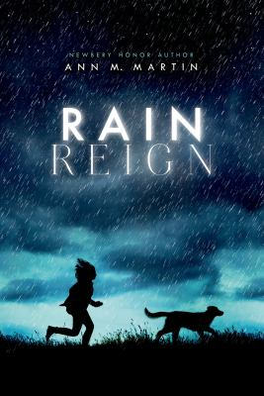 | Martin, Ann M. Rain Reign. New York: Feiwel  and Friends, 2014.  Rose loves homonyms and keeps a list of new homonyms she hears. Rose has Asperger’s, so rules and routines are very important to her. She does not always get along with her classmates, but everyone likes her dog Rain. Then a hurricane comes through town, and Rain gets lost. Rose has to find Rain, but when she does, she may lose her all over again.  Wilson’s MHR, ALSC Notable book, NCSS Notable SS Bk
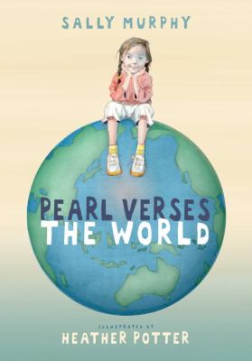 | Murphy, Sally. Pearl Verses the World.  Somerville, MA: Candlewick, 2011.  Three people live in Pearl’s house – Pearl, her mom, and her granny. Her granny is old and sick and will not be getting better. Pearl tries to do her best at school, but her teacher only wants poems that rhyme. Pearl tries to find a good book at the library, but it is hard to find books about girls with dying grannies. Pearl writes down her thoughts, worries and fears as part of one long verse of poem.  Wilsons MHR
Palacio, R.J. Wonder. New York: Alfred A.
Knopf, 2012.

August is 10 years old, but he has never gone to school. He looks very different from other kids because his face is deformed. His mom and dad want him to go to school, but he is not sure that he is ready. When he goes to school, it is not so bad, but he still does not have friends. He is not sure if some of the kids even like him. He wonders if anyone will ever be able to look past his face, and like him for who he really is inside.

Wilsons MHR, Black Eyed Susan, Librarian rec
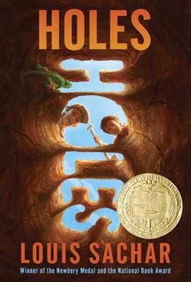  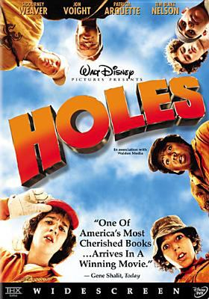 | Sachar, Louis. Holes. DVD. Directed by  Andrew Davis. Burbank, CA: Walt Disney Pictures, 2003.  Stanley and the men in his family have been under a curse for years. He is always in the wrong place at the wrong time. As a result, he gets sent to a boys’ detention center for something he did not do. Once he is there, he and the other boys have to spend all day digging holes. It is supposed to build character, but Stanley thinks there may be more to those holes. The warden may be looking for something, and Stanley wants to find out what it is.  Newbery, Wilson’s MHR

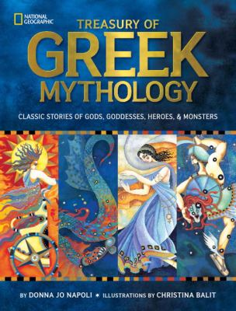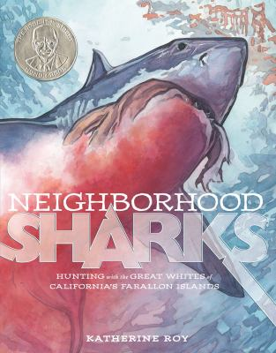

Nonfiction Books

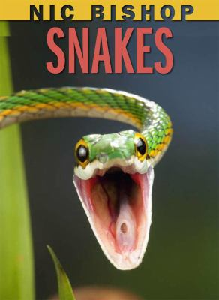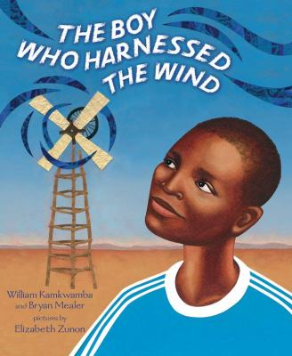

Bishop, Nic. Snakes. New York: Scholastic,
2012.

Snakes are predators. There are snakes on almost every continent on Earth. Some snakes are smaller than a shoelace, and some are huge and weight 400 pounds. They may not have ears or very good eyesight, but they still have amazing senses that help them find their prey.

NSTA Notable Science book
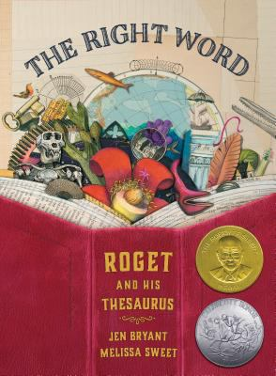 | Bryant, Jen. The Right Word. Grand Rapids,  MI: Eerdmans, 2014.  As a kid, Peter Roget liked to write lists.  He had a whole book of word lists – he liked to have the right word to say what he meant. When he grew up, he published his book of word lists. Other people made similar books, but Peter’s book was better. He worked on his book and made it bigger and easier to use.  He wanted to make sure anyone who needed help would be able to find just the right word.  Sibert, Caldecott honor, NCSS Notable SS book
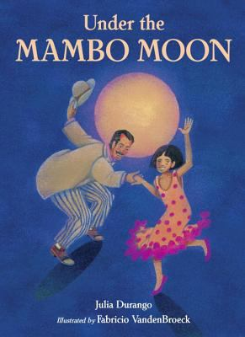 | Durango, Julia. Under the Mambo Moon.  Watertown, MA: Charlesbridge, 2011.  In the summer Marisol helps out her Papi at his music store. People come in and out looking for the dance music they like. Some like salsa, some like the samba, and others are experts at the tango. Sometimes at the end of the night, Marisol gets to stay up a little later and dance with her Papi under the mambo moon.  Wilson’s MHR
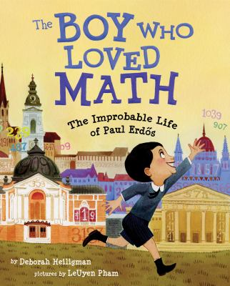 | Heiligman, Deborah. The Boy Who Loved  Math. New York: Roaring Brook, 2013.  Paul had trouble sitting still and following school rules. But he loved math and numbers. He was so amazing at math that he was famous by the time he was twenty. However, he had not learned how to cook, do laundry or drive a car. He spent the rest of his life traveling and living with one mathematician or another, because he was great at math but could not take care of himself.  Wilson’s MHR, ALSC Notable book
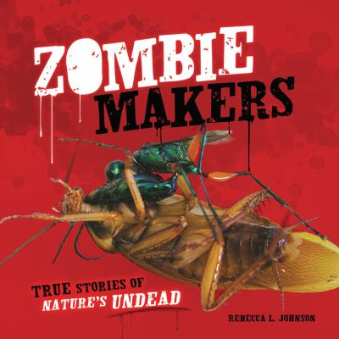 | Johnson, Rebecca L. Zombie Makers.  Minneapolis, MN: Millbrook, 2013.  Human zombies may not exist. But there are things that can take over creatures and turn them into slaves. There are worms that can make crickets drown themselves in water and wasps that paralyze cockroaches so they will watch their new eggs. There are even parasites that will make rats fearless so that they walk right up to a cat and get eaten.  Wilson’s MHR
Kamkwamba, William and Bryan Mealer.
The Boy Who Harnessed the Wind.
New York: Dial Books, 2012.

When William was a teenager, his village was in trouble. There was no rain for a long time and people ran out of food. There was no money for William to go to school, so he went to the library instead. He learned about windmills and that they can make electricity and pump water. He decided to build a windmill to help his village. Everyone thought he was crazy, but he finally built it and brought light to his village.

NSTA Notable Science bk, NCSS Notable SS bk
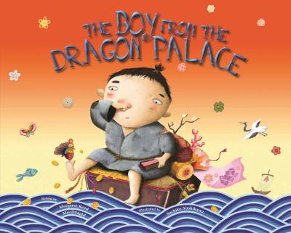 | MacDonald, Margaret Reed. The Boy From  the Dragon Palace. Chicago: Albert Whitman, 2011.  One day a poor flower seller tosses all his flowers in the sea. The Dragon King rewards him and gives him a little boy who will bring him good luck. When the man cooks dinner for the boy, the boy blows his nose and out comes gold. The next day after dinner the boy blows his nose and out comes a palace. Each day the boy brings more good fortune, but the flower seller only becomes greedier and greedier.  Wilson’s MHR
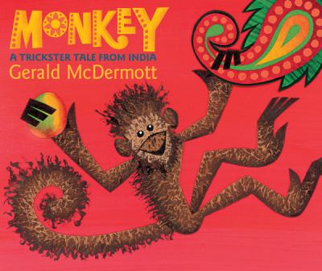 | McDermott, Gerald. Monkey: A Trickster Tale  from India. Boston: Houghton Mifflin Harcourt, 2011.  Monkey is so fast; no one can catch him. Crocodile wants to catch Monkey so he can eat him. Monkey wants to eat the delicious mangoes on the island in the river. Crocodile offers Monkey a ride to try and drown him, but Monkey is too smart. Crocodile’s teeth may be sharp, but his mind is too dull to fool monkey.  Wilson’s MHR
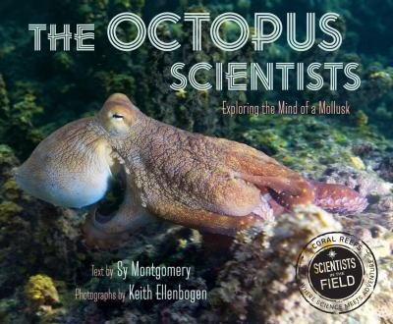 | Montgomery, Sy. The Octopus Scientists.  Boston: Houghton Mifflin Harcourt, 2015.  Octopuses are hard to find. They can hide in holes, change color, and even make their skin bumpy to look like a rock. Scientists want to study Pacific octopuses and figure out what they eat and how they think, but first they have to find them. They spend two weeks swimming, diving, and searching to learn all that they can about these creatures.  Wilson’s MHR
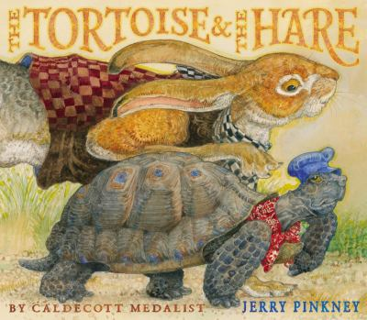 | Pinkney, Jerry. The Tortoise and the Hare.  New York: Little, Brown, 2013.  The tortoise and the hare are having a race. Before the fox says, “go”, the rabbit already has a head start. The rabbit leaps over animals and runs through water, making a mess along the way. The tortoise keeps moving along, slow and steady. If an animal needs help along the way, the tortoise gives him a ride. In the end, all the animals are cheering for the tortoise to win as he keeps moving, slow and steady.  Wilson’s MHR
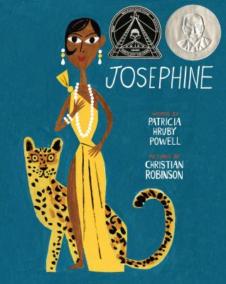 | Powell, Patricia Hruby. Josephine. San  Francisco: Chronicle, 2014.  Josephine loved to dance. She loved to dance so much she would take any job in a theater just to be near the dancers. She learned the dances so she could step in when someone was sick. When she finally got to dance on stage, she stole the show. She could only dance in black theaters in America, but in Europe things were different. She went to France, where she danced for everyone and became a star.  Coretta Scott King honor, Sibert honor
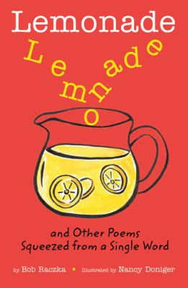 | Raczka, Bob. Lemonade. New York:  Roaring Brook, 2011.  Sometimes it can be hard to write a poem. This book shows you how to make a poem using just one word. Start with just one word for the title – like “Lemonade.” Then use the letters from the title word to form new words that make up a poem. After reading these simple poems, you will want to sit down and come up with some of your own.  Wilson’s MHR, ALSC Notable book
Roy, Katherine. Neighborhood Sharks.
New York: David Macaulay Studio, 2014.

Great white sharks have been around for millions of years. They are perfect predators with torpedo shaped bodies, warm blooded brains, excellent vision, and sharp teeth.
Great white sharks love to eat elephant seals. So every September they follow the seals to San Francisco. Scientists follow the sharks to tag them and learn more about them.

NSTA Notable Science book
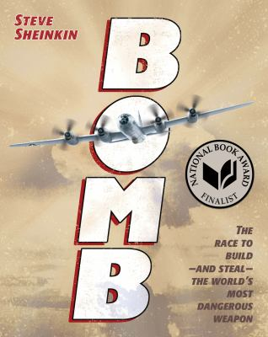 | Sheinkin, Steve. Bomb. Crawfordsville, IN:  RR Donnelley & Sons, 2012.  During World War II, American was in a race to build the first nuclear bomb. A scientist discovered that you could split an atom and use the energy to create a bomb. Scientists knew they had to build a bomb before Germans did. This story describes the scientists who worked on the project and the spies who tried to steal the secret of the bomb.  NCSS Notable SS book
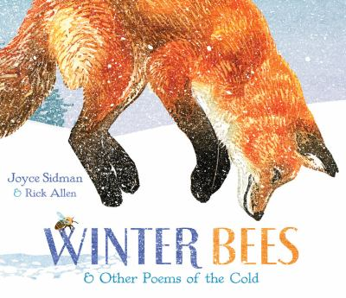 | Sidman, Joyce. Winter Bees. Boston:  Houghton Mifflin Harcourt, 2014.  In the winter, you do not see many animals. These poems describe what different animals do in the winter – swans, moose, snakes, wolves, and bees. There are even poems about winter trees and a special plant that is the first to come up in the spring. Next to each poem, there are facts about how each animal survives in the cold of winter.  Wilson’s MHR

Nonfiction Books to Browse
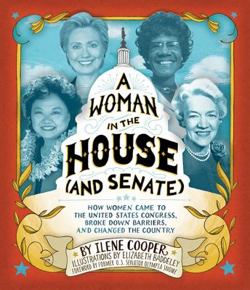 | Cooper, Ilene. A Woman in the House  (and Senate). New York: Abrams, 2014.  For a long time, women in America lived with a myth of where a “woman’s place” should be.  This book tells the story of the journey from before women could vote to today. Today there are a record number of women in Congress and the Senate.  NCSS Notable SS book
Cooper, Michael L. Fighting Fire! New York:
Henry Holt, 2014.

Read about the ten deadliest fires in American history. This book includes the great fires of Boston, New York, Chicago, Baltimore and San Francisco. Each fire led to new firefighting techniques and technologies.

NCSS Notable SS book
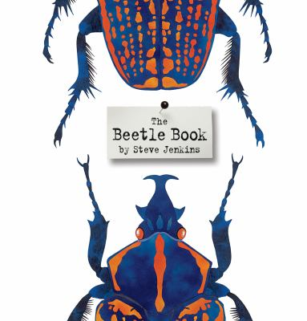 | Jenkins, Steve. The Beetle Book. Boston:  Houghton Mifflin Harcourt, 2012.  On Earth, one quarter of all plants and animals are beetles. Beetles are found in lots of different shapes, sizes, and colors. This book will tell you everything you want to know about beetles.  Wilson’s MHR
Napoli, Donna Jo. Treasury of Greek
Mythology. Washington, DC: National Geographic, 2011.

Learn about all the Greek gods, goddesses, heroes, and monsters. Besides Zeus, read about Apollo, Poseidon and Orion. There is a section at the end with all the gods and goddesses, and their Greek and Roman names.
Wilson’s MHR, ALSC Notable book

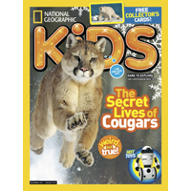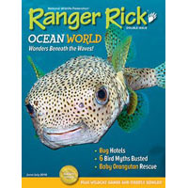

Magazines

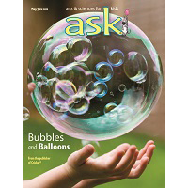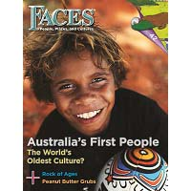

Ask magazine (Arts & Sciences)
http://shop.cricketmedia.com/magazines/ASK-Magazine-for-Kids.html

This magazine has a different theme each month –
like “shipwrecks” or “bubbles and balloons”. There are articles, photographs, comics and games all relating to the theme for the month.

Online features: Teacher guides for each issue.
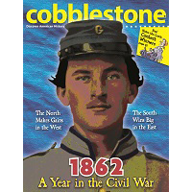 | Cobblestone magazine (History)  http://shop.cricketmedia.com/cobblestone.html  This is a magazine for history lovers. Each issue focuses on a certain time in American history. There are short articles, maps, poems and photos about that time in history.  Online features: Teacher guides for each issue.
Faces magazine (People, Places, and Cultures)
http://shop.cricketmedia.com/FACES-Magazine-for-Kids.html

This magazine will take you around the globe. Each issue focuses on a different place or culture in our world. There are articles about people, animals, sports, and crafts and activities to do as well.

Online features: Teacher guides for each issue.
National Geographic Kids (Nature and the world)
http://kids.nationalgeographic.com/

Learn amazing facts about animals and places in our world. Each month there are articles, weird-but-true facts, games, and amazing photos.

Online Features: Kids section with videos, animal facts, games, and jokes.
Ranger Rick magazine (Wildlife and nature)
http://www.nwf.org/Kids/Ranger-Rick.aspx

If you love animals, this is a great magazine for you.
This magazine focuses on animals with articles about creatures and their habitats, wildlife conservation, along with animal photography.

Online features: Animal facts, games, family section with crafts and activity ideas, and an educator section.
Notes and Sources

Selection Sources: All materials were chosen from these sources.

ALSC Children’s Notable List

Every year the Association for Library Service to Children selects the best children’s books for this list. The list includes the Caldecott, Geisel, Newbery, Belpré, and Sibert award winners.

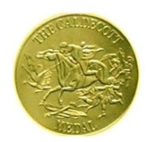 | Caldecott Medal  Every year the Association for Library Service to Children gives this award to the artist who created the best picture book of the year. There is one winner and a few honor books.
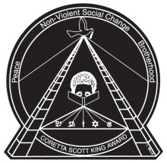 | Coretta Scott King Award  Every year the American Library Association gives these awards to African American authors and illustrators of the best books that appreciate African American culture and values.
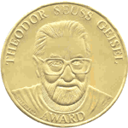 | Geisel Award  Every year the Association for Library Service to Children gives this award to the author and illustrator of the best book for early readers that year. There is one winner and a few honor books.
Maryland Black Eyed Susan Award

This is a children’s choice award given each year to authors and illustrators of outstanding children’s books. The winners are selected and voted on by students in Maryland schools.

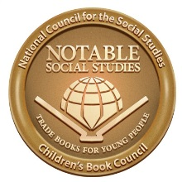 | NCSS Notable Social Studies Books  Each year the National Council for the Social Studies selects outstanding books, written for children in grades K through 8th, that focus on human relations from a broad range of cultural experiences.
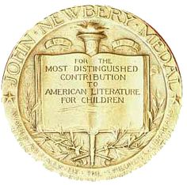 | Newbery Medal  Every year the Association for Library Service to Children gives this award to the author of most distinguished chapter book of the year. There is one winner and a few honor books.
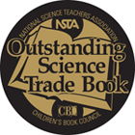 | NSTA Outstanding Science Books  Each year the National Science Teachers Association selects outstanding books, written for children in all grades, that build reading skills and also teach science content.
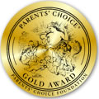 | Parent’s Choice: Magazine Award Winners  This is a panel of educators, scientists, librarians and parents that select the best books and media for children.  http://www.parents-choice.org/ award.cfm?p_code=p_per&thePage=magazine
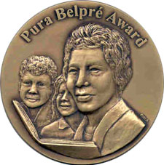 | Pura Belpré Award  Every year the Association for Library Service to Children and REFORMA give this award to a Hispanic author and illustrator for the best children’s books that celebrate Latino culture. There are two winners and a few honor books.
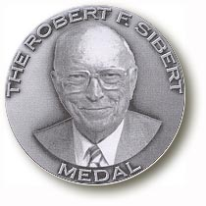 | Sibert Award  Every year the Association for Library Service to Children gives this award to authors and illustrators of the best nonfiction books of the year. There is one winner and a few honor books.
Tina Dattoli, Media Specialist

Tina Dattoli is the media specialist at Whittier Elementary School in Frederick, Maryland with over 15 years’ experience. She is also a graduate of the McDaniel program.
Wilson’s Children’s Core Collection
Most Highly Recommended List

This is a database of over 13,000 books for grades kindergarten through sixth, selected and recommended by librarians. Most highly recommended books are considered a must read.

Image Sources
- All book images were taken from the Frederick County Public Library catalog: http://catalog.fcpl.org/
- All magazine images were taken from the Parents’ Choice site: http://www.parents-choice.org/award.cfm
- All award images were taken from Google images.

