Scan the QR codes to go to each author’s website.

You might like these other graphic novels:

If you liked
You might like
these other books about summer vacations:
School's out and Lucy is off to her summer favorite place: Pierson Point, Maine. As she tries to forget her worries about starting middle school and her Dad's new girlfriend, Lucy can't get there soon enough.
This One Summer…
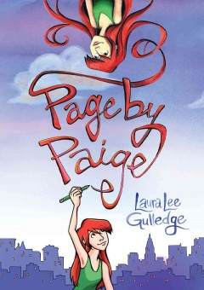
Paige has just moved to New York with her family, and she's having some trouble adjusting to the big city. Using her sketchbook, she tries to make sense of her new life, including trying out her secret identity as an artist.

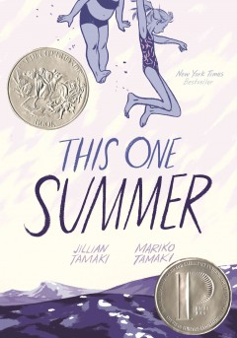

Belly's never been the kind of girl that things happen to. But the summer Belly turned pretty was the summer that changed everything: for better, and for worse.
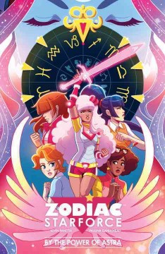
They're an elite group of teenage girls with magical powers who have sworn to protect our planet against dark creatures! Known as the Zodiac Starforce, these girls aren't just combating math tests, they're also battling monsters!
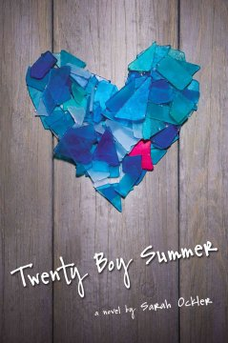
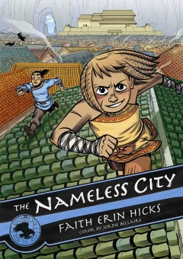
The fate of the City rests in the hands of Rat, a native, and Kaidu, one of the Dao, the latest occupiers, and the two must somehow work together if the City is to survive.

Best friends Anna and Frankie are inseparable, and they are headed to California for a beach vacation, determined to have the Absolute Best Summer Ever. But Anna is keeping a secret that could alter their friendship forever.

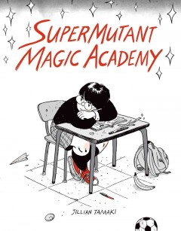
SuperMutant Magic Academy is a prep-school for mutants and witches. Science experiments go awry, bake sales are upstaged, and the new kid at school is a cat who will determine the course of human destiny.

If you liked
This One Summer…

You might like these other books by
Jillian Tamaki:

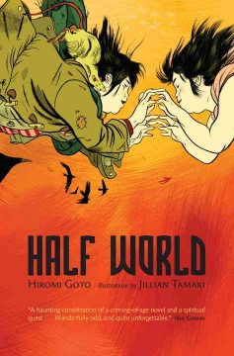
Melanie Tamaki is human but her parents are not. They are from Half World, a limbo between our world and the afterlife, and her father is still there. When her mother disappears, Melanie must follow her to Half World and neither of them may return alive.
Skim, aka Kimberly Keiko Cameron is stuck in a private girls' school in Toronto. When a classmate's boyfriend kills himself, the school goes into mourning overdrive, and everyone is trying to find something to hold on to and something to believe in.

Scan this QR code to go to Jillian Tamaki’s website.
Bibliography
Day, Karen. A Million Miles from Boston. New York, Wendy Lamb Books, 2011.
Goto, Hiromi, and Jillian Tamaki. Half World. New York, Viking, an Imprint of Penguin Group (USA) Inc., 2010.
Gulledge, Laura Lee. Page by Paige. New York, Amulet Books, 2011.
Han, Jenny. The Summer I Turned Pretty. New York, Simon & Schuster Books for Young Readers, 2009.
Hicks, Faith Erin, and Jordie Bellaire. The Nameless City. NY, NY, First Second, 2016.
Ockler, Sarah. Twenty Boy Summer. London, Little, Brown Young Readers, 2010.
Panetta, Kevin, and Paulina Ganucheau. Zodiac Starforce: by the Power of Astra. Milwaukie, OR, Dark Horse Books, 2016.
Tamaki, Jillian. SuperMutant Magic Academy. Montreal, Quebec, Drawn & Quarterly, 2015.
Tamaki, Mariko, and Jillian Tamaki. Skim. Toronto, Groundwood Books, 2008.
Tamaki, Mariko, and Jillian Tamaki. This One Summer. New York, NY, First Second, 2014.

Selection Sources and Images
Follett Titlewave. Follett Titlewave summaries: "Follett Titlewave." Follett School Solutions, Inc., 2017. Web. 26 Jan. 2017.
Hoover Library. Wilson’s Middle and Junior High Core Collection. McDaniel College, 2017. Web. 26 Jan. 2017.
Hoover Library. Wilson’s Senior High Core Collection. McDaniel College, 2017. Web. 26 Jan. 2017.

