What to Read?
A List of Great Books
from Mrs. Wellen

Carol Wellen
SLM 503

Diversity:
People with Autism and
Autism Spectrum Disorders (ASD)

What is Autism?

Autism is a condition where a person’s brain works differently from most people’s brains. They are very sensitive to sights, sounds, smells and touch. The lights in the library may flicker and bother them. Recess or lunch in the cafeteria may be too loud for them. They may not like to be touched or hugged.
Kids with autism often talk differently. Some kids may not say much at all, while some will talk all the time and not listen to what you are saying. Certain words may be confusing, like saying “that’s a piece of cake”. They do not understand that means something is easy; they think it is time for dessert. Faces are also confusing. If you have a sad face but say you are fine, they will believe your words because they do not understand your sad face.
The most important thing to remember about autistic kids is that they are kids just like you. They still want to play. They want to have friends. If you want to know a little more about kids with autism, here are some books you can read.

Adapted from “Ten Things Your Child with Autism Wishes You Knew”
on the Autism Speaks website at www.autismspeaks.org

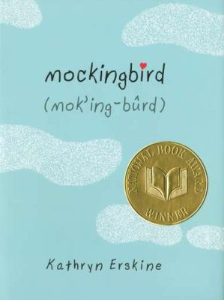 | Erskine, Kathryn. Mockingbird. New York: Philomel, 2010.  Devon never got the chance to finish the wooden chest for his Eagle project. Now he is dead, his dad is sad, and his sister Caitlin is trying to find closure. But Caitlin has Asperger’s, so she never knows the right thing to say. With some help and practice, Caitlin learns how to be a friend, and how to help herself and her father heal.  Wilson’s MHR, ALSC Notable Book
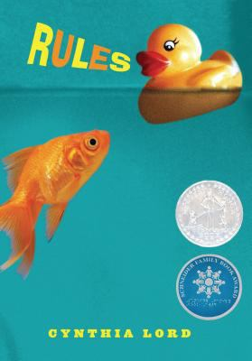 | Lord, Cynthia. Rules. New York: Scholastic, 2006.  Catherine feels like everyone knows her as “the girl with the autistic brother”. She tries to help her brother David by teaching him the “rules” – rules like “no toys in the fish tank.” She hopes to make a new friend when Kristi moves in next door. Instead, she feels more comfortable hanging out with Jason, a boy she meets at her brother’s doctor’s office. Now she is not sure what to do – hang out with her new, cool friend, or stay true to herself.  Wilson’s MHR
Montgomery, Sy. Temple Grandin. Boston: Houghton
Mifflin Harcourt, 2012.

Temple Grandin is an amazing woman. She has autism, but she never let that stop her from doing everything she wanted to do. She went to college and studied animal science. She used her special way of thinking to help her learn about cattle. Now she is an expert and many people use her ideas and follow her advice about raising farm animals.
NCSS Notable SS book, ALSC Notable Book
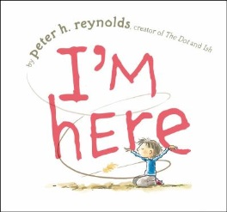 | Reynolds, Peter. I’m Here. New York: Atheneum, 2011.  A little boy sits alone on a playground. The noise of all the other children is too much for him. He is not really alone though. He enjoys the breeze, the leaves, and the adventures in his imagination. He can even enjoy a friend who comes over to play with him in his quiet world.  Wilson’s MHR
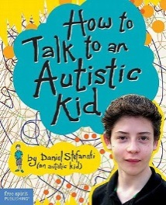 | Stefanski, Daniel. How to Talk to an Autistic Kid.  Minneapolis, MN: Free Spirit Publishing, 2011.  Daniel is an autistic kid. He is not so different from other kids, but he does have trouble talking with other people. He feels lonely because he does not have a lot of friends. He wants to help other kids understand what it is like to be autistic. Then, they can feel comfortable making friends with an autistic kid like him.  Wilson’s MHR

