Carol Wellen
SLM 502
Library Facilities Design
Whittier Elementary School, Frederick, MD 21702

ALA/AASL Standards and Elements Addressed
- 3.2 Access to Information. Demonstrate ability to develop solutions for addressing physical, social, and intellectual barriers to equitable access to resources and services. Facilitate access to information in print, non-print, and digital formats.
- 5.3 Personnel, Funding and Facilities. Organize library facilities to enhance the use of information resources and services and to ensure equitable access to all resources for all users.

Philosophy, Vision, and Mission Statement

Philosophy and Freedom to Read:
Interesting and informative books and materials will always be available in our library.
Read anything and everything you want. I will never tell you that you cannot read a certain book.
Everyone in our school can use the library. I will try to keep it open as much as possible, including before school and during lunches.
Ask the librarian if you are interested in something that we do not have. I will help you find it or see if we can add it to our library.
Don’t worry. There are no permission forms or fees required to use anything in the library.

(Adapted from the ALA’s Library Bill of Rights at www.ala.org)
Vision:
The Whittier School vision is “to nurture, support, and promote success for all in order to achieve their full potential to become productive citizens and lifelong learners.”
This vision relates to AASL Standards 3.2 and 5.3 which requires that all students be given “equitable access” to library resources and services. In order for all students to be lifelong learners, everyone must have access to the media center.
Mission statement of the library:
- To be an integral part of Whittier ES and its surrounding community
- To provide collaboration with staff to create authentic learning for all students
- To provide quality resources and instruction to students and staff
- To encourage staff and students in becoming effective users and ideas and information
- To promote lifelong reading and learning for pleasure and for information

(From the Whittier Media Center website at education.fcps.org/whes/media_missionstatement)

Reflection on Facility Design
School Description
Whittier Elementary School opened in 1998. It is a community school, where many of the teachers and staff live in the community. There is an active PTA with 228 members, as well as 213 parent and grandparent volunteers who help during the school day. The Whittier mascot is the “Heroes”, which celebrates all heroes but especially military heroes. The large number of military families means there is a strong sense of patriotism at the school. Special populations at the school include military families, nontraditional families, ELL students, and students with special needs including physical disabilities and blindness.
After evaluating the current Whittier library, I noticed the following benefits:
- The open floor plan is nice and inviting.
- The current setup easily allows two classes to use the library at the same time. – one class in the back instructional area, and another class in the middle book exchange area.
- The circulation desk by the main door allows students to be greeted by the library assistant and made to feel welcome.

These areas could be improved:
- No group project area.
- No actual seating for informal reading.
- There are no sign translations into Spanish or Braille for the visually impaired students.

The MSDE Standard 6 for Facilities requires five areas in a media center: an administrative area, an instructional area, a production and group project area, an (informal) reading area, and a study and research area. Looking at the current media center, I only saw three of these areas. There was no designated area for student productions or group projects, and there was no area for informal reading. I redesigned the layout of the library to allow for those five key areas.

Administrative Area (A)
The administrative area includes the circulation desk, media specialist office, and storage room. The circulation desk is still by an entrance, but it has been relocated to the back of the room. This allows the media assistant to supervise the new informal reading area and group project area. Behind the circulation desk is a new bulletin board which can be used to display student work or recommendations. The media specialist mentioned that she would like more space to display student work. There is also an office for the media specialist, and a storage room that is mostly used for A/V storage.

Instructional Area (I)
There are two instructional areas in the library. One is a main instruction area with tables, chairs, and a Promethean board. This main area seats up to 32 people. This is where the library lessons are taught, and the space is also used for staff meetings and parent nights after school. The layout of this area has not changed, but it has been relocated to the front of the room to better use the space. The second instruction area is used for biweekly book exchanges. This area is at the back of the room by the circulation desk, and it consists mainly of an open space with a rug for students to sit as they wait for instructions on choosing their books. A set of display shelves has been added by the circulation desk to highlight new or award winning books.

Project and Production Area (P)
The current library has a few round tables and chairs available, but no designated group project space. By moving the class instructional area to the front of the room, the library now has room to have an area with tables and chairs where students can work on projects. This area would be easy to turn into a makerspace by including some “maker” items on nearby shelves. There is also a conference room adjacent to the library that connects through a doorway. This room is used primarily by the administration for conferences and meetings, but it is often empty and unused. With a posted schedule, this would be another space that could be utilized by students for projects. Both of these areas are in the same corner as the Media Production room, which is used for the morning announcements. Those media tools are now close to the project areas where they could be used by students as part of a maker space.

Reading area (R)
There are no informal reading areas in the current library. Once students choose books to read, they sit on the floor to read them. The new space has a designated reading area with modular benches and bean bag chairs, near the circulation desk so it is convenient to sit as soon as students have checked out a book. There are also five more bean bag chairs on one side of the room for additional seating.

Study and Research Area (S)
The current study and research areas in the library are spread out all over the room. The new design moves all of these into one central area. The new area includes online computer stations with room for 12 computers. There is a separate station in the corner with two additional computers. All of the reference books and atlases will now be in this area. There is also a separate table in this area away from the group project area, that could be used for students who need a quiet place to work or study.
Other Areas of Consideration

OPAC
The online card catalog can be accessed at any of the computer stations. However, the current setup has most of the computers in one area. The new design puts a computer station at the end of each of the Everybody and Fiction shelves, so that it is convenient to search for a book as they are browsing the stacks.

Display Areas
Currently the tops of the low shelves serve as the main display area to highlight books. I have added a set of display shelves near the circulation desk for additional display. There are also 3 shelves near the main instructional area that can be used for display or to highlight books.

ADA Regulations and Signage
The media center meets ADA regulations for physical access with the low shelves and wide aisles. The current computer stations are at the right height for wheelchairs, but they are crowded together so it would be different for someone in a wheelchair to squeeze in. The new computer area has spaced the computers out more so there is more room for a wheelchair to fit in.
The signs in the media center are large, clear, and easy to read, in English. New signs will be added that list the sections in Spanish, and in Braille.

Location of Materials
Everybody, Fiction, and Graphic Novels
The Everybody and Fiction books are shelved on low shelves in the center of the library. The new design has moved them from a horseshoe shape to a more traditional setup of stacks. Everybody is on one side, Fiction is on another side. This change allows the Graphic Novels to be displayed on shelves near the Fiction books.

Nonfiction
The nonfiction books are on taller shelves around the perimeter of the media center. The new design does not change their location, but the sections are shifted around the room to better use the space.

Reference, Nonprint, Magazines
The reference books are currently are the back of the room where they go unnoticed. The new design relocates reference books to be part of the study and research area. The nonprint items are also at the back of the room, near the main instructional area. They have been moved to the front of the room, still near the main instructional area. There are few magazines available, and they currently take up very little space in a corner of the library. They have been moved to a more central location closer to the main instructional area.

Library Furniture
Furniture | Source
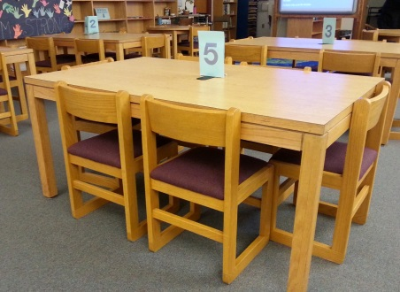  Rectangular table and chairs | Current media center
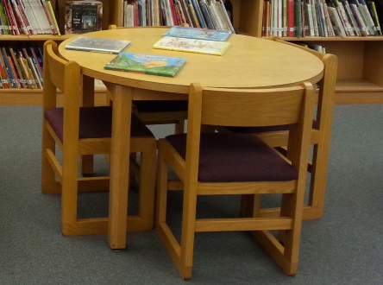  Circular table and chairs | Current media center
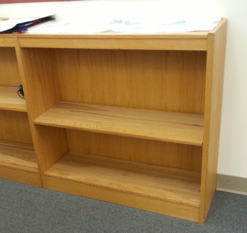  24 in bookcase with two shelves | Current media center
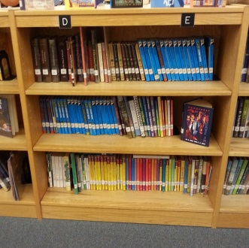  36 in bookcase with three shelves | Current media center
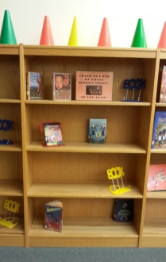  48 in bookcase with four shelves | Current media center
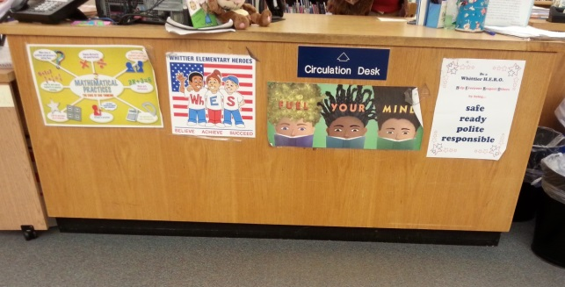  Circulation desk | Current media center
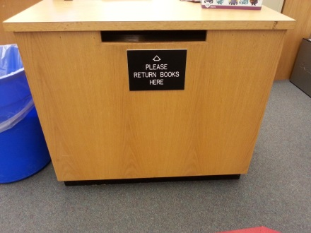  Book return | Current media center
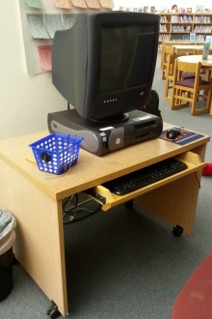  Desktop computer and table | Current media center
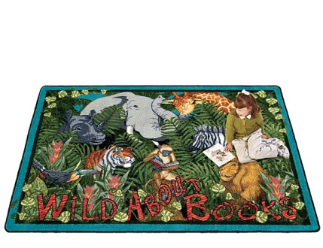  Area Rugs | Demco  Joy Carpets Wild About Books  Wild About Books Carpet 13'2"W x 10'9"D  Item #: WF12151340  http://www.demco.com/goto?BLS167724&ALL0000&es=20160128150520135617
Modular Benches | Demco  Tenjam Swerve Bench 16-1/2" x 47" x 18"  Item #: WF13708650  http://www.demco.com/goto?BLS305247&ALL0000&es=20160125194731346092
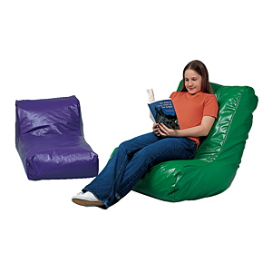  Bean bag high back chair | Demco  Bean Bag Seating-High-Back Chair 36" x 24" x 30"  Item #: WF13595570  http://www.demco.com/goto?BLS184576&ALL0000&es=20160125195339697227
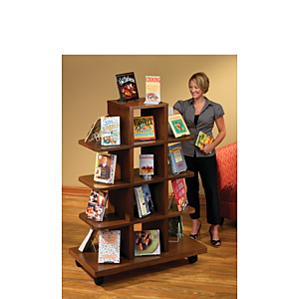  Display shelves | Demco  Paladin Mobile Grid Display 62" x 39" x 24"  Item #: WF14927330  http://www.demco.com/goto?blk00173205&intcmp=BMR_00173205
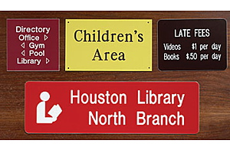  Signs | Demco  Custom Engraved Sign 6"Hx10"W B  Item #: WE12705110  http://www.demco.com/goto?PRD12705110

Sources
Barack, Lauren. "The Heart of the School." School Library Journal 60.1 (2014): 32. ProQuest. Web. 2 Apr. 2015.

Dattoli, Tina (Library Media Specialist). Discussion with the author, January 2016.

Demco, Inc. Demco, Inc., n.d. Web. 26 January 2016. <http://www.demco.com/>

Fielding, Randall. “Designing Schools for 21st Century Learning”. YouTube. The Pearson Foundation and The Mobile Learning Institute, 18 Oct. 2009. Web. 18 Jan. 2016.

Formanack, Gail. “Designing a facility: Making it a place where every student succeeds.” Every Student Succeeds @ your library. American Association of School Librarians Conference, Pittsburg, PA, October 2005. 18 Jan. 2016.

Standards for School Library Media Programs in Maryland. Baltimore, MD: Maryland State Department of Education, 2007. Print.

Whittier Elementary Library Redesign
P
Production and A/V Room

2 – 24 in shelves
4 – 48 in shelves

4 – 48 in shelves

3 – 48 in shelves
3 – 48 in shelves
5 – 48 in shelves

4 – 36 in shelves

4 – 36 in shelves

4 – 36 in shelves

4 – 36 in shelves

3 – 36 in shelves

3 – 36 in shelves
16 – 48 in shelves

Bulletin board
Exit to Hallway

A
A
NONFICTION – 800s

600s – NONFICTION – 700s

Media Storage and A/V Storage

Circulation
Desk

I
EVERYBODY

FICTION

GRAPHIC NOVELS

Media Spc Computer Cart

PC

DISPLAY/ PROFESSIONAL

Modular benches

Display shelves

FICTION

FICTION

000 100 200 300 – NONFICTION – 400 500 600

Area Rug

Areas
A Administrative Area
I Instructional Area
P Project and Production Area
R Reading Area
S Study and Research Area
2 – 24 in shelves
PC

Exit to Hallway

Online Computer Stations

Online Computer Stations

REF

REF

PC

PC

PC

PC

PC

PC

PC

PC

PC

PC

Key
PC Desktop Computer
BB Bean Bag
DISPLAY/ MAGAZINES

NON PRINT

NONFICTION
900s
EVERYBODY

EVERYBODY

S
S
R
R
P
P
I
A
BB

BB

BB

BB

BB

BB

BB

BB

Promethean

Window
Window
Window
Area Rug

Conf Room (can double as Group Project space)

Media Specialist Office

Vice Principal’s Office

